PHILIPPINE Bidding Documents

Republic of the Philippines

Procurement
of
Goods

First Edition
May 2025

Preface

This Philippine Bidding Documents (PBD) for the Government of the Philippines (GoP) for the procurement of Goods through [Competitive Bidding, Limited Source Bidding, Competitive Dialogue, or Unsolicited Offer with Bid Matching] have been prepared by the GoP for use by all branches, agencies, departments, bureaus, offices, or instrumentalities of the government, including government-owned and/or -controlled corporations (GOCC), government financial institutions (GFI), state universities and colleges (SUC), and local government units (LGU) and autonomous regional government use in projects that are financed in whole or in part by the GOP or any foreign government/foreign or international financing institution in accordance with the provisions of the Implementing Rules and Regulations (IRR) of Republic Act (RA) No. 12009.

The Bidding Documents shall clearly and adequately define, among others: (a) the objectives, scope, and expected outputs and/or results of the proposed contract; (b) the eligibility requirements of Bidders, such as track record to be determined by the Head of the Procuring Entity (HoPE); (c) the expected contract duration, the estimated quantity in the case of procurement of goods, delivery schedule and/or time frame; and (d) the obligations, duties, and/or functions of the winning Bidder.

In order to simplify the preparation of the Bidding Documents for each procurement, the PBD groups the provisions that are intended to be used unchanged in Section II. Instructions to Bidders (ITB) and in Section IV. General Conditions of Contract (GCC). Data and provisions specific to each procurement and contract should be included in Section III. Bid Data Sheet (BDS); Section V. Special Conditions of Contract (SCC); Section VI. Schedule of Requirements; and Section VII. Technical Specifications. The forms to be used are provided in Section VIII. Philippine Bidding Document Related Forms.

Prudence must be exercised to check the relevance of the provisions of the PBD against the requirements of the specific Goods to be procured. In addition, each section is prepared with notes intended only as information for the Procuring Entity or the person drafting the Bidding Documents. They shall not be included in the final documents, except for the notes introducing Section VIII. Philippine Bidding Document Related Forms where the information is useful for the Bidder. The following general directions should be observed when using the documents:

- All the documents listed in the Table of Contents are normally required for the procurement of Goods. However, they should be adapted as necessary to the circumstances of the particular Project.

- Specific details, such as the “name of the Procuring Entity” and “address for bid submission,” should be furnished in the ITB, BDS, and SCC. The final documents should contain neither blank spaces nor options.

- This Preface and the footnotes or notes in italics included in the Invitation to Bid, BDS, SCC, Schedule of Requirements, and Specifications are not part of the text of the final document, although they contain instructions that the Procuring Entity should strictly follow. The Bidding Documents should not contain footnotes except Section VIII. Philippine Bidding Document Related Forms since these provide important guidance to Bidders.

- The cover page should be modified as required to identify the Bidding Documents and date of issue.

- The Project title page should be modified as required to identify the Project title and number, name and address of the Procuring Entity.

- If modifications must be made to the bidding requirements, they can be presented in the BDS. Modifications for specific Project or Contract details should be provided in the SCC as amendments to the Conditions of Contract. For easy reference and completion, clauses from the PBD and SCC shall appear in bold type face on Section II. Instructions to Bidders and Section IV. General Conditions of Contract, respectively.



Republic of the Philippines
Department of Education
REGION VIII
SCHOOLS DIVISION OF BILIRAN
Larrazabal, Naval, Biliran

Procurement
of
Goods

PROVISION OF FOOD AND VENUE FOR THE CONDUCT OF VARIOUS TRAINING ACTIVITIES OF SDO BILIRAN FOR CY 2027

(Goods-EPA-2027-001)

TABLE OF CONTENTS

Glossary of Acronyms, Terms, and Abbreviations 6
Definition of Terms 8
Section I. Invitation to Bid 10
Section II. Instructions to Bidders 13
Section III. Bid Data Sheet 42
Section IV. General Conditions of Contract 46
Section V. Special Conditions of Contract 60
Section VI. Schedule of Requirements 63
Section VII. Technical Specifications 64
Section VIII. Philippine Bidding Document Related Forms 66

Glossary of Acronyms, Terms, and Abbreviations

ABC – Approved Budget for the Contract.

BAC – Bids and Awards Committee.

BDS – Bid Data Sheet.

BIR – Bureau of Internal Revenue.

BSP – Bangko Sentral ng Pilipinas.

CDA - Cooperative Development Authority.

CIF – Cost Insurance and Freight.

CIP – Carriage and Insurance Paid.

COS – Contract of Service.

CPI – Consumer Price Index.

DDP – Delivered Duty Paid.

DOLE – Department of Labor and Employment.

DTI – Department of Trade and Industry.

EXW – Ex works.

FCA – “Free Carrier” shipping point.

FOB – “Free on Board” shipping point.

GCC - General Conditions of Contract.

GFI – Government Financial Institution.

GOCC – Government-Owned and/or –Controlled Corporation.

GoP – Government of the Philippines.

GPPB – Government Procurement Policy Board.

HoPE – Head of Procuring Entity.

INCOTERMS – International Commercial Terms.

IRR – Implementing Rules and Regulations.

ITB – Instructions to Bidders.

JO – Job Order.

LCB- Lowest Calculated Bid.

LCRB – Lowest Calculated Responsive Bid.

LGU – Local Government Unit

LoC – Letter of Credit.

MAB – Most Advantageous Bid.

MARB – Most Advantageous Responsive Bid.

MEARB – Most Economically Advantageous Responsive Bid.

MYCA – Multi-Year Contracting Authority.

NFCC – Net Financial Contracting Capacity.

NGA – National Government Agency.

PhilGEPS - Philippine Government Electronic Procurement System.

PSA – Philippine Statistics Authority.

RA No. – Republic Act Number.

SARB – Single Advantageous Responsive Bid.

SCC - Special Conditions of Contract.

SCRB – Single Calculated Responsive Bid.

SEARB – Single Economically Advantageous Responsive Bid.

SEC – Securities and Exchange Commission.

SLCC – Single Largest Completed Contract.

UN – United Nations.

Definition of Terms

Bid – a signed offer, proposal, or quotation submitted by a supplier, manufacturer, distributor, contractor, consultant, or service provider in response to the requirements of the Procuring Entity as stated in the Bidding Documents. (IRR, Section 5[c]).

Bidder – a supplier, manufacturer, distributor, contractor, consultant, and service provider, whether public or private, who submits a Bid in response to the requirements of the Procuring Entity as stated in the Bidding Documents. (IRR, Section 5[d]).

Bidding Documents – the documents issued by the Procuring Entity as the basis for Bids, furnishing all information necessary to prospective Bidder to prepare a Bid for the Goods, Infrastructure Projects, and Consulting Services required by the Procuring Entity. (IRR, Section 5[e]).

Contract – refers to the agreement entered into between the Procuring Entity and the Supplier or Manufacturer or Distributor or Service Provider for procurement of Goods and Services; Contractor for Procurement of Infrastructure Projects; or Consultant or Consulting Firm for Procurement of Consulting Services; as the case may be, as recorded in the Contract Form signed by the parties, including all attachments and appendices thereto and all documents incorporated by reference therein.

Contract Price - the price payable to the Supplier under the Contract for the full and proper performance of its contractual obligations.

Effective Date of the Contract – the date indicated in the contract. However, the Supplier shall commence performance of its obligations only upon receipt of the Notice to Proceed.

Foreign-funded Procurement or Foreign-Assisted Project – refers to the acquisition of Goods, Consulting Services, and the contracting for Infrastructure Projects by the Government of the Philippines which are wholly or partly funded by foreign loans or grants pursuant to a Treaty or International or Executive Agreement.

Framework Agreement – is a procurement strategy which shall be in the nature of an option contract between the Procuring Entity and the Bidder that stipulates the terms and conditions to be applied in subsequent contracts for the procurement of Goods, Infrastructure Projects, and Consulting Services with a single or multiple contractor, manufacturer, supplier, distributor, consultant, and service provider to expand the pool of prospective Bidders, take advantage of economies of scale, minimize the administrative burden of conducting separate procurement activities, and generate time and money savings. (IRR, Section 16.2).

Goods – refer to (i) all items, supplies, and materials, whether in the nature of equipment, furniture, stationery, materials for construction, or personal property of any kind, needed in the transaction of public businesses or in the pursuit of any government undertaking, project or activity; or (ii) general support services which pertain to all types of services except Consulting Services and Infrastructure Projects, such as the repair and maintenance of equipment and furniture, as well as trucking, hauling, janitorial, security, and related or analogous services. Personnel Services or individual COS or JO engagements do not fall under this definition; (IRR, Section 5[n])

MARB – refers to the award criteria in the procurement of Goods where the considerations for the award of contract are the eligibility of the bidder, the responsiveness of its bid to the technical requirements, and the most advantageous bid in reference to the highest rated offer based on the quality component of the bid.

MEARB – refers to the award criteria in the procurement of Goods where the considerations for the award of contract are the eligibility of the bidder, and the responsiveness of its bid to the technical requirements, and the determination of the most economically advantageous bid in reference to the quality-price ratio allocated to the technical and financial components of the bid.

Online submission – pertains to the submission of the bid for Goods and the bid envelopes containing the technical and financial components of the bid through electronic means or through the electronic bidding facility of the PhilGEPS.

Project – refers to a specific or identified procurement covering Goods, Infrastructure Projects or Consulting Services. A Procurement Project shall be described, detailed, and scheduled in the Project Procurement Management Plan prepared by the agency which shall be consolidated in the procuring entity's Annual Procurement Plan.

Services - means those services ancillary to the supply of the Goods, such as transportation and insurance, and any other incidental services, such as installation, commissioning, provision of technical assistance, training, and other such obligations of the Supplier covered under the Contract.

Supplier – refers to a citizen, or any corporate body or commercial company duly organized and registered under the laws where it is established, habitually established in business and engaged in the manufacture or sale of the merchandise or performance of the general services covered by its Bid. Supplier as used in these Bidding Documents may likewise refer to a manufacturer, distributor, contractor, or consultant, or service provider.

Verified Report - the report submitted by the Implementing Unit to the HoPE setting forth its findings as to the existence of grounds or causes for termination and explicitly stating its recommendation for the issuance of a Notice to Terminate.

Section I. Invitation to Bid
Notes on the Invitation to Bid

The Invitation to Bid provides information that enables potential Bidders to decide whether to participate in the procurement at hand. The Invitation to Bid shall be:

- In line with the principle of transparency and competitiveness and to ensure the widest possible dissemination thereof, all invitations to bid shall be published continuously by the Procuring Entity for seven (7) calendar days on the PhilGEPS website, in any conspicuous place reserved for this purpose in the premises of the Procuring Entity, and in the website or social media platforms of the Procuring Entity, if available, or such other channels as may be authorized by the Government Procurement Policy Board (GPPB), and the website prescribed by the foreign government/foreign or international financing institution, if applicable.

- For justifiable reasons, a Procuring Entity that cannot publish procurement opportunities on its website, social media platform, or such other channels authorized by the GPPB shall publish its Invitation to Bid, at least once, in a newspaper of general nationwide circulation;

Apart from the essential items listed in the Bidding Documents, the Invitation to Bid should also indicate the following:

- The availability of the Bidding Documents, which shall commence on the date the Invitation to Bid is first published and continue until the deadline for submission and receipt of bids;

- The place where the Bidding Documents may be acquired or the website where it may be downloaded;

- The deadline for the submission and receipt of bids from the last day of publication of the Invitation to Bid;

- The procurement strategy/ies (e.g. Life Cycle Assessment and Life Cycle Cost Analysis, Subcontracting, Pooled Procurement); and

- The bid award criterion/criteria (e.g., the application of a margin of preference in bid evaluation).

The Invitation to Bid should be incorporated in the Bidding Documents. The information contained in the Invitation to Bid must conform to the Bidding Documents, particularly to the relevant information in the BDS.

Invitation to Bid for

PROVISION OF FOOD AND VENUE FOR THE CONDUCT OF VARIOUS TRAINING ACTIVITIES OF SDO BILIRAN FOR CY 2027(Goods-EPA-2027-001)

- The DepEd, SDO Biliran, through the FY 2027 NEP intends to apply the sum of Four Million Five Hundred Forty-Eight Thousand Three Hundred Fifty Pesos (P4,548,350.00) being the Approved Budget for the Contract (ABC) to payments under the contract for Provision of Food and Venue for the Conduct of Various Training Activities of SDO Biliran for CY 2027(Goods-EPA-2027-001). Bids received in excess of the ABC shall be automatically rejected at bid opening.

- The DepEd, SDO Biliran now invites bids for the above procurement project. Delivery of the Goods is required on January to December 2027. Bidders should have completed, at least five (5) years from the date of submission and receipt of bids, contracts similar to the Project. The description of an eligible bidder is contained in the Bidding Documents, particularly, in Section II. Instructions to Bidders.

- Bidding will be conducted through competitive bidding procedures using a non-discretionary “pass/fail” criterion as specified in the IRR of RA No. 12009.

Bidding is restricted to Filipino citizens/sole proprietorships, partnerships, or organizations with at least sixty percent (60%) interest or outstanding capital stock belonging to citizens of the Philippines, and to citizens or organizations of a country the laws or regulations of which grant similar rights or privileges to Filipino citizens, pursuant to RA No. 5183.

- Interested Bidders may obtain further information from DepEd, SDO Biliran and inspect the Bidding Documents at the address given below from 8:00 AM to 5:00 PM, Mondays to Fridays except holidays.

- A complete set of Bidding Documents may be acquired by interested Bidders on October 27, 2026 to November 17, 2026 from 8:00 AM to 5:00 PM, Mondays to Thursdays except holidays from the address given below upon payment of the applicable fee for the Bidding Documents, pursuant to the latest Guidelines issued by the GPPB, in the amount of Five Thousand Pesos (P5,000.00).

It may also be downloaded free of charge from the website of the Modernized Philippine Government Electronic Procurement System (MPhilGEPS) and the website of the Procuring Entity, provided that Bidders shall pay the applicable fee for the Bidding Documents not later than the submission of their bids.

- The DepEd, SDO Biliran will hold a Pre-Bid Conference on November 4, 2026 @9:00 A.M at Conference Room, DepEd, SDO-Biliran, Larrazabal, Naval, Biliran and/or through video conferencing via google meet which shall be open to prospective Bidders.

- Bids must be duly received by the Bids and Awards Committee (BAC) Secretariat through manual submission at the office address indicated below on or before November 17, 2026 @ 8:30 A.M. Late bids shall not be accepted.

- All Bids must be accompanied by Bid Security in any of the acceptable forms and in the amount stated in ITB Clause 16.1.

Bid opening shall be on November 17, 2026 @ 9:00 A.M at Conference Room, DepEd, SDO-Biliran, Larrazabal, Naval, Biliran. Bids will be opened in the presence of the Bidders’ representatives who choose to attend the activity. A link will be provided to those bidder/s who wish to join the activity via google meet.

- The Head of Procuring Entity of DepEd, SDO Biliran reserves the right to reject any and all bids, declare a failure of bidding, or not award the contract at any time prior to contract award in accordance with Section 70 of R.A. No. 12009, without incurring any liability to the affected Bidder or Bidders.

- For further information, please refer to:

DR. JOSEPHINE M. CASAS
Head, BAC Secretariat
Telephone No. 09453372765/09667926880

- You may visit the following websites:

For downloading of Bidding Documents: www.PhilGEPS.gov.ph or depedbiliran.org

October 23, 2026

______________________
ARVIN T. ELATICO CPA, JD
BAC Chairperson

Section II. Instructions to Bidders
Notes on the Instructions to Bidders

This Section of the Bidding Documents provides the information necessary for Bidders to prepare responsive bids, in accordance with the requirements of the Procuring Entity. It also provides information on bid submission, eligibility check, opening and evaluation of bids, post-qualification and on the award of contract.

This Section contains provisions that shall not be changed or modified. Any amendment shall be reflected on Section III. Bid Data Sheet which consists of provisions that supplement, amend, or specify in detail, information or requirements included in this Section.

Matters governing performance of the Supplier, payments under the contract, or those affecting the risks, rights, and obligations of the parties under the contract are not normally included in this Section, but rather under Section IV. GCC and/or Section V. SCC. If duplication of a subject is inevitable in other sections of the document prepared by the Procuring Entity, prudence must be exercised to avoid contradictions between clauses dealing with the same matter.

TABLE OF CONTENTS
A. General 16
1) Scope of Bid 16
2) Source of Funds 16
3) Corrupt, Fraudulent, Collusive, and Coercive Practices 16
4) Conflict of Interest 17
5) Eligible Bidders 19
6) Bidder’s Responsibilities 20
7) Origin of Goods 22
8) Subcontracts 23
B. Contents of Bidding Documents 23
9) Pre-Bid Conference 23
10) Clarification and Amendment of Bidding Documents 23
C. Preparation of Bids 24
11) Language of Bids 24
12) Documents Comprising the Bid: Technical and Financial Components 24
13) Bid Prices 26
14) Bid Currencies 27
15) Bid Validity 27
16) Bid Security 28
17) Format and Signing of Bids 30
18) Sealing and Marking of Bids 30
D. Submission and Opening of Bids 31
19) Deadline for Submission of Bids 31
20) Late Bids 31
21) Modification and Withdrawal of Bids 31
22) Opening and Preliminary Examination of Bids 32
E. Evaluation and Comparison of Bids 33
23) Process to be Confidential 33
24) Clarification of Bids 33
25) Domestic Preference 33
26) Detailed Evaluation and Comparison of Bids 34
27) Post-Qualification 36
28) Reservation Clause 38
F. Award of Contract 38
29) Contract Award 38
30) Signing of the Contract 39
31) Performance Security 40
32) Notice to Proceed 41
33) Protest Mechanism 41

General

Scope of Bid
  - The Procuring Entity, named in the BDS invites bids for the Project with Identification Number which shall be specified in the BDS.

  - The Project is composed of number of lots or items as provided in the BDS, the details of which are described in Section VII. Technical Specifications.

Source of Funds
The Procuring Entity has a budget or has received funds from the Funding Source named in the BDS, and in the amount indicated in the BDS. It intends to apply part of the funds received for this Project to cover eligible payments under the contract.

Corrupt, Fraudulent, Collusive, and Coercive Practices
  - Unless otherwise specified in the BDS, the Procuring Entity, as well as the Bidders and Suppliers, shall observe the highest standard of ethics during the procurement and execution of the contract. In pursuance of this policy, the Procuring Entity:

    - defines, for purposes of this provision, the following terms under existing laws, rules, and regulations:
- “corrupt practice” means an act by which officials in the public or private sectors improperly and unlawfully enrich themselves, others, or induce others to do so, by misusing the position in which they are placed, and includes the offering, giving, receiving, or soliciting of anything of value to influence the action of any such official in the procurement process or in contract execution; entering, on behalf of the government, into any contract or transaction manifestly and grossly disadvantageous to the same, whether or not the public officer profited or will profit thereby, and similar acts as provided in RA No. 3019.

- “fraudulent practice” means a misrepresentation of facts for purposes of influencing a procurement process or the execution of a contract to the detriment of the Procuring Entity, which includes collusive practices among Bidders (prior to or after bid submission) designed to establish bid prices at artificial, non-competitive levels and to deprive the Procuring Entity of the benefits of free and open competition.

- “collusive practices” means a scheme or arrangement between two or more Bidders, with or without the knowledge of the Procuring Entity, designed to establish bid prices at artificial, non-competitive levels.

- “coercive practices” means harming or threatening to harm, directly or indirectly, persons, or their property to influence their participation in a procurement process, or affect the execution of a contract;

- “obstructive practice” is

- deliberately destroying, falsifying, altering or concealing of evidence material to administrative proceedings or investigation or making false statements to investigators in order to materially impede administrative proceedings or investigation of the Procuring Entity or any foreign government/foreign or international financing institution relative to allegations of a corrupt, fraudulent, coercive, or collusive practice; and/or threatening, harassing, or intimidating any party to prevent the latter from disclosing its knowledge of matters relevant to the administrative proceedings or investigation or from pursuing such proceedings or investigation; or

- acts intended to materially impede the exercise of the inspection and audit rights of the Procuring Entity or any foreign government/foreign or international financing institution herein.

    - Undertakes to reject a proposal for award upon prima facie determination that the Bidder recommended for award has engaged in any of the prohibited practices mentioned in this Clause for purposes of competing for the contract.
  - Further, the Procuring Entity will seek to impose the maximum civil, administrative, and/or criminal penalties available under applicable laws on individuals and organizations deemed to be involved in any of the practices mentioned in ITB Clause 3.1(a).

Furthermore, the Funding Source and the Procuring Entity reserve the right to inspect and audit records and accounts of a Bidder or Supplier in the bidding for and performance of a contract themselves or through independent auditors as reflected in the GCC Clause 3.

Conflict of Interest
  - All Bidders found to have conflicting interests shall be disqualified to participate in the procurement at hand, without prejudice to the imposition of appropriate administrative, civil, and criminal sanctions. A Bidder may be considered to have conflicting interests with another Bidder in any of the events described in paragraphs (a) through (c) below and a general conflict of interest in any of the circumstances set out in paragraphs (d) and (f) below:

- A Bidder has controlling shareholders or beneficial owners in common with another Bidder;

- A Bidder receives or has received any direct or indirect subsidy from any other Bidder;

- A Bidder has the same legally authorized representative as that of another Bidder for purposes of this bid;

- A Bidder has a relationship, directly or through third parties, that puts them in a position to have access to information about or influence on the bid of another Bidder or influence the decisions of the Procuring Entity regarding this bidding process; This may include a firm or an organization that lends, or temporarily seconds, its personnel to firms or organizations that are engaged in consulting services for the preparation related to procurement for or implementation of the project, if the personnel would be involved in any capacity on the same project;

- A Bidder who participated as a consultant in the preparation of the design or technical specifications of the Goods and related services that are the subject of the bid.

- A Bidder who lends, or temporarily seconds, its personnel to firms or organizations which are engaged in consulting services for the preparation related to procurement for or implementation of the project, if the personnel would be involved in any capacity on the same project.

  - All Bidding Documents shall be accompanied by an omnibus sworn statement of the Bidder that it is not related, by consanguinity or affinity up to the third level, to the HoPE, Procurement Agent (if engaged), the head of the Project Management Office (PMO), the End-User or Implementing Unit or any members of the Bids and Awards Committee (BAC), Technical Working Group (TWG), and BAC Secretariat.

  - The Bidder shall also disclose the ultimate beneficial ownership of an entity. Failure to comply shall be a ground for the automatic disqualification of the bid in consonance with Section 59 of the IRR. For this reason, relation to the aforementioned persons within the third civil degree of consanguinity or affinity shall automatically disqualify the Bidder from participating in the procurement of contracts of the Procuring Entity notwithstanding the act of such persons inhibiting themselves from the procurement process. This Clause shall apply to the following persons and affiliates:

- In the case of individuals or sole proprietorships, to the Bidders and their spouses;

- In the case of partnerships, to the partnership itself and its partners;

- In the case of cooperatives, to the cooperative itself and members of the board of directors, general manager or chief executive officer;

- A partnership, joint venture or consortium which is blacklisted or which has blacklisted member/s or partner/s, as well as a person or entity who is a member of a blacklisted joint venture or consortium, are, likewise not allowed to participate in any government procurement during the period of suspension or blacklisting; and

- In the case of corporations, a single stockholder, together with their relatives up to the third civil degree of consanguinity or affinity, and their assignees, holding at least twenty percent (20%) of the shares therein, its chairperson and president, shall be blacklisted after they have been determined to hold the same controlling interest in a previously blacklisted corporation or in two corporations that have been blacklisted; the corporations of which they are part of shall also be blacklisted.

Eligible Bidders
  - Only Bids found to be legally, technically, and financially eligible will be evaluated. For procurement of Goods, the following persons shall be eligible to participate in this bidding:

- Duly-licensed Filipino citizens or sole proprietorships;

- Partnerships duly organized under the laws of the Philippines and of which at least sixty percent (60%) of the interest belongs to citizens of the Philippines;

- Corporations duly organized under the laws of the Philippines, and of which at least sixty percent (60%) of the outstanding capital stock belongs to citizens of the Philippines;

- Cooperatives duly organized under the laws of the Philippines; and

- Persons or entities forming themselves into a Joint Venture (JV), i.e., a group of two (2) or more persons or entities that intend to be jointly and severally responsible or liable for a particular contract: Provided, however, that Filipino ownership or interest of the JV concerned shall be at least sixty percent (60%). For this purpose, Filipino ownership or interest shall be based on the contributions of each of the members of the joint venture as specified in their Joint Venture Agreement (JVA); Provided, further, that the primary purpose of each member of the JV must be similar to or related with the requirements of the project to be bid out.

  - Foreign Bidders may be eligible to participate when any of the following circumstances exist, as specified in the BDS:

- When provided for under any treaty or international or executive agreement as provided in Section 4 of the IRR;

- When the foreign supplier is a citizen, corporation, or association of a country, the laws or regulations of which grant reciprocal rights or privileges to citizens, corporations, or associations of the Philippines;

- When the Goods sought to be procured are not available from local suppliers; or

- When there is a need to prevent situations that defeat competition or restrain trade.

  - GOCCs may be eligible to participate only if they can establish that they (a) are legally and financially autonomous, (b) operate under commercial law, and (c) are not attached agencies of the Procuring Entity.

  - The Bidder must have completed, within a period of ten (10) years from the submission of the bid, unless a shorter period is indicated in the Invitation to Bid and BDS, a Single Largest Completed Contract (SLCC) that is similar to the procurement project to be bid, and whose value must be equivalent to at least fifty percent (50%) of the ABC, adjusted to current prices using the Philippine Statistics Authority (PSA) consumer price indices.

  - If the Procuring Entity determines that it is necessary to adopt a different SLCC requirement to ensure broader Bidder participation while establishing their technical capacity, it may allow Bidders to present a combination of contracts completed within the same period, provided their total value is at least fifty percent (50%) of the ABC, thus:

- The Bidder should have completed at least one (1) similar contract amounting to at least 25% of the ABC; and

- The Bidder should have completed other contracts, whether similar or not, with an aggregate amount of at least 25% of the ABC.

For this purpose, the Procuring Entity may clarify in the BDS the definition or description of what it considers to be a similar project, which must be germane to the kind, class, or genus of goods or services to be procured, guided by the principle of proportionality and fit-for-purpose approach.
  - The Bidder must submit a computation of its Net Financial Contracting Capacity (NFCC), which must be at least equal to the ABC to be bid, calculated as follows:

NFCC = [(Current assets minus current liabilities) (15)] minus the value of all outstanding or uncompleted portions of the projects under ongoing contracts, including awarded contracts yet to be started coinciding with the contract to be bid.

The values of the domestic Bidder’s current assets and current liabilities shall be based on the latest Audited Financial Statements (AFS) submitted to the BIR not earlier than two (2) years prior to date of bid submission.

For purposes of computing the foreign Bidders’ NFCC, the value of the current assets and current liabilities shall be based on their latest AFS prepared in accordance with International Financial Reporting Standards.

If the Bidder opts to submit a committed Line of Credit, it must be at least equal to ten percent (10%) of the ABC to be bid. Provided that, if issued by a foreign bank, it shall be confirmed or authenticated by a local bank.

Bidder’s Responsibilities
  - The Bidder or its duly authorized representative shall submit an omnibus sworn statement, in the form prescribed in Section VIII. Philippine Bidding Document Related Forms, as required in ITB Clause 12.1(viii).

  - Before submitting their bids, the Bidder is deemed to be knowledgeable with all existing laws, decrees, ordinances, acts and regulations of the Philippines which may affect this Project in any way.

  - The Bidder undertook the following responsibilities:

- Took steps to carefully examine and ensure full understanding and comprehension of the Bidding Documents, its requirements, clauses, and provisions;

- Acknowledged all conditions, local, or otherwise, affecting the implementation of the contract;

- Made an estimate of the facilities available and needed for the contract to be bid, if any;

- Complied with the responsibility to inquire, or secure the Supplemental Bid Bulletin(s) as provided under ITB Clause 10.4;

- Ensured that it is not “blacklisted” or barred from bidding by the Government of the Philippines (GoP) or any of its agencies, offices, corporations, or LGUs, including foreign government, or foreign or international financing institutions whose blacklisting rules have been recognized by the GPPB; by itself or by reason of its relation, membership, association, affiliation, or controlling interest with another blacklisted person or entity;

- Ensured that each of the documents submitted in satisfaction with the bidding requirements is an authentic copy of the original, complete, and that all statements and information provided therein are true and correct;

- Authorized the HoPE or its duly authorized representative/s to verify all the documents submitted;

- Ensured that the signatory is the duly authorized representative of the Bidder, and granted full power and authority to do, execute, and perform any and all acts necessary to participate, submit the bid, to sign, and execute the ensuing contract, accompanied by the duly-notarized Special Power of Attorney, Board, or Partnership Resolution, or Secretary’s Certificate, whichever is applicable;

- Complied with the disclosure provision under Section 81 and 82 of RA No. 12009 and its IRR, in relation to other provisions of RA 3019;

- Complied with existing labor laws and standards, in the case of procurement of services. Moreover, the Bidder undertakes to:

- Ensure the entitlement of workers to wages, hours of work, safety and health and other prevailing conditions of work as established by national laws, rules and regulations; or Collective Bargaining Agreement (CBA); or arbitration award, if and when applicable.

In case there is a finding by the Procuring Entity or the Department of Labor and Employment (DOLE) of underpayment or non-payment of workers’ wages and wage-related benefits, the Bidder agrees that the performance security or portion of the contract amount shall be withheld in favor of the complaining workers pursuant to appropriate provisions of RA No. 12009, without prejudice to the institution of appropriate actions under the Labor Code, as amended, and other social legislations.

- Comply with Occupational Safety and Health Standards (OSHS) and correct deficiencies, if any.

In case of imminent danger, injury, or death of the worker, the Bidder undertakes to suspend contract implementation pending clearance to resume from the DOLE Regional Office, in compliance with the Work Stoppage Order; and

- Inform the workers of their conditions of work, labor clauses under the contract specifying wages, hours of work, and other benefits under prevailing national laws, rules and regulations; or CBA; or arbitration award, if and when applicable, through posting in two (2) conspicuous places in the establishment’s premises.

- Ensured that it did not give or pay, directly or indirectly, any commission, amount, fee, or any form of consideration, pecuniary or otherwise, to any person or official, personnel, or representative of the government in relation to any procurement project or activity.

- Examined all instructions, forms, terms, and specifications in the Bidding Documents.

- Determined and complied with all matters pertaining to the contract to be bid, including but not limited to: (i) the location and the nature of this Project; (ii) climatic conditions; (iii) transportation facilities; and (iv) other factors that may affect the cost, duration, and execution or implementation of this Project.

- Ensured that all information in the Bidding Documents, including bid or supplemental bid bulletin/s issued, are correct and consistent. The Procuring Entity shall not assume any responsibility regarding erroneous interpretations or conclusions by the prospective or eligible Bidder out of the data furnished by the Procuring Entity.

Failure to observe any of the above responsibilities shall be at the risk of the Bidder concerned.

  - Further, the Bidder shall bear all costs associated with the preparation and submission of its Bid, and the Procuring Entity shall in no case be responsible or liable for those costs, regardless of the conduct or outcome of the bidding process.

In case of failure of bidding, the Bidding Documents fee may be applied in the re-bidding for the same Project.

  - Furthermore, the Bidder should be aware that the Procuring Entity will accept bids only from those that have paid the applicable fee for the Bidding Documents at the office indicated in the Invitation to Bid.

Origin of Goods

Unless otherwise indicated in the BDS, there is no restriction on the origin of Goods other than those prohibited by a decision of the United Nations (UN) Security Council taken under Chapter VII of the Charter of the UN.

Subcontracts
  - Unless otherwise specified in the BDS, the Bidder may subcontract portions of the Goods to an extent as may be approved by the HoPE and as stated in the BDS. However, the subcontracted portion shall not exceed twenty percent (20%), or a different percentage of the ABC, on a per project basis, as approved by the GPPB.

  - Subcontracting of any portion of this Project shall not relieve the Bidder from any liability or obligation that may arise from the contract.

  - Subcontractors must meet the eligibility criteria and submit the same eligibility documents as the general contractor. Failure of a subcontractor to meet the eligibility criteria does not affect the eligibility of the general contractor for the Project. In such case, the portion intended to be subcontracted to the ineligible subcontractor shall be assumed by the general contractor.

  - Subcontracting arrangement, if allowed, including the time of submission of the eligibility documents of the subcontractor, shall be disclosed in the BDS.

Contents of Bidding Documents

Pre-Bid Conference
  - If so specified in the BDS, a pre-bid conference shall be held either at the Procuring Entity’s physical address and/or online through videoconferencing, webcasting, or similar technology, or a combination thereof, on the date indicated therein, to clarify and address the Bidders’ questions on the technical and financial components of this Project.

  - The pre-bid conference shall be held at least twelve (12) calendar days before the deadline for the submission and receipt of bids, but not earlier than seven (7) calendar days from the posting of the invitation to bid and other bidding documents in the PhilGEPS.

  - Bidders are highly encouraged to attend the pre-bid conference to fully understand the Procuring Entity’s requirements. While non-attendance of the Bidder will in no way prejudice its bid. The Bidder is deemed to know any changes and/or amendments to the Bidding Documents, as may be provided in the Supplemental Bid Bulletin.

The proceedings of the pre-bid conference shall be recorded, and the corresponding minutes shall be prepared not later than five (5) calendar days after the pre-bid conference. The minutes shall be made available to prospective Bidders not later than five (5) days upon written request.

  - Decisions of the BAC amending any provision of the Bidding Documents shall be issued in writing through a Supplemental Bid Bulletin at least seven (7) calendar days before the deadline for the submission and receipt of bids.

Clarification and Amendment of Bidding Documents
  - Prospective Bidders may request for clarification on and/or interpretation of any part of the Bidding Documents. Such request must be in writing and submitted to the BAC of the Procuring Entity at the address or electronic mail indicated in the BDS or through the electronic bidding facility of PhilGEPS, as may be applicable, at least ten (10) calendar days before the deadline set for the submission and receipt of Bids.

  - The BAC shall respond to the said request by issuing a Supplemental Bid Bulletin duly signed by the BAC Chairperson. It shall be made available to all those who have properly secured the Bidding Documents, at least seven (7) calendar days before the deadline for the submission and receipt of Bids.

  - Supplemental Bid Bulletins may also be issued upon the Procuring Entity’s initiative for purposes of clarifying or modifying any provision of the Bidding Documents not later than seven (7) calendar days before the deadline for submission and receipt of Bids. Any modification to the Bidding Documents shall be identified as an amendment.

  - Any Supplemental Bid Bulletin issued by the BAC shall also be posted in the PhilGEPS, in any conspicuous place in the premises of the Procuring Entity, and on the website or social media platforms of the Procuring Entity, if available, or such other channels as may be authorized by the GPPB. It shall be the responsibility of all prospective Bidders, including those who have properly secured the Bidding Documents, to inquire and secure Supplemental Bid Bulletins that may be issued by the BAC. However, Bidders who have submitted bids before the issuance of the Supplemental Bid Bulletin must be accordingly informed by the BAC and be allowed to modify or withdraw their bids prior to the deadline for the submission and receipt of bids in accordance with ITB Clause 21.

Preparation of Bids

Language of Bids

The eligibility requirements or statements, the bids, and all other documents to be submitted to the BAC must be in English. If the eligibility requirements or statements, the bids, and all other documents submitted to the BAC are in foreign language other than English, it must be accompanied by a translation of the documents in English. The documents shall be translated by the relevant foreign government agency, the foreign government agency authorized to translate documents, or a registered translator in the foreign Bidder’s country. The Bidder shall cause the authentication of the translated documents and shall be authenticated by the appropriate Philippine foreign service establishment or post or the equivalent office having jurisdiction over the foreign Bidder’s affairs in the Philippines. The English translation shall govern, for purposes of interpretation of the bid.

However, for Contracting Parties to the Apostille Convention, the documents shall be authenticated through an apostille by the Competent Authority, as defined in Section 20.9.2 of [the] IRR, except for countries identified by the DFA that will still require legalization (red ribbon) by the relevant Embassy or Consulate.

Documents Comprising the Bid: Technical and Financial Components
  - The first bid envelope shall contain the following technical documents, including the eligibility documents:

- PhilGEPS Certificate of Registration (Platinum Membership);

- Statement of SLCC;

- NFCC Computation or committed Line of Credit (LoC);

- Statement of all its ongoing government and private contracts, including contracts awarded but not yet started, if any, whether similar or not similar in nature and complexity to the contract to be bid;

- [if applicable] JVA or in the absence of a JVA, duly notarized statements from all potential JV partners stating that they will enter into and abide by the provisions of the JVA in the event that the bid is successful;

- Bid Security in the prescribed form and amount in accordance with ITB Clause 16, and validity period under ITB Clause 15;

- Technical Specifications, which may include production or delivery schedule, manpower requirements, or after-sales service or parts, if applicable;

- Omnibus Sworn Statement; and

- For foreign Bidders claiming eligibility by reason of their country’s extension of reciprocal rights to Filipinos, a certification from the relevant government office of their country stating that Filipinos are allowed to participate in their government procurement activities for the same item or product.

  - The second bid envelope shall contain the following financial documents:

- Bid Form which includes the Bid price;

- Price Schedules in accordance with ITB Clause 13.1; and

- [if applicable] Certificate of Domestic Preference, in accordance with ITB Clause 25.

  - Whenever necessary, modifications may be made to the foregoing components specifically for major and specialized procurement to suit the particular needs of the Procuring Entity, subject to the approval of the GPPB.

  - All bids that exceed the ABC shall not be accepted. Unless otherwise indicated in the BDS, for foreign-funded procurement, the ABC shall be applied as the ceiling to bid prices provided the following conditions are met:

- Bidding Documents are obtainable free of charge on a freely accessible website. If payment of Bidding Documents is required by the Procuring Entity, payment could be made upon the submission of bids.

- The Procuring Entity has procedures in place to ensure that the ABC is based on recent estimates made by the responsible unit of the Procuring Entity and that the estimates reflect the quality, supervision and risk, and inflationary factors, as well as prevailing market prices, associated with the types of works or goods to be procured.

- The Procuring Entity has trained cost estimators in estimating prices and analyzing bid variances.

- The Procuring Entity has established a system to monitor and report bid prices relative to ABC and engineer’s/procuring entity’s estimate.

- The Procuring Entity has established a monitoring and evaluation system for contract implementation to provide feedback on actual total costs of goods and works.

However, the GoP and the foreign government, or foreign or international financing institutions may agree to waive the foregoing conditions.

Bid Prices
  - The Bidder shall accomplish the Price Schedule Form as prescribed by the Procuring Entity, which may include the following details:

- For Goods offered from within the Philippines:

- The price of the Goods quoted EXW (ex works, ex factory, ex warehouse, ex showroom, or off-the-shelf, as applicable);

- The cost of all customs duties and sales and other taxes already paid or payable;

- The cost of transportation, insurance, and other costs incidental to delivery of the Goods to their final destination; and

- The price of other (incidental) services, if any, listed in the BDS.

- For Goods offered from abroad:

- Unless otherwise stated in the BDS, the price of the Goods shall be quoted Delivery Duty Paid (DDP) with the place of destination in the Philippines as specified in the BDS. In quoting the price, the Bidder shall be free to use transportation through carriers registered in any eligible country. Similarly, the Bidder may obtain insurance services from any eligible source country.

- The price of other (incidental) services, if any, listed in the BDS.

- For Services, based on the form which may be prescribed by the Procuring Entity, in accordance with existing laws, rules and regulations.

  - The Bidder shall accomplish the appropriate Price Schedule included herein, stating the unit prices, total price per item, the total amount and the expected countries of origin of the Goods to be supplied under this Project. The Bidder shall fill in rates and prices for all items of the Goods described in the Price Schedule, which shall be presented and computed using up to two (2) decimal places, unless otherwise indicated in the BDS.

  - If the Instructions to Bidders specifically allow partial bids, bids not addressing or providing all of the required items in the Bidding Documents including, where applicable, the Price Schedule, shall be considered non-responsive and shall be automatically disqualified. However, when no price or a zero (0) or a dash (-) is indicated in a required item in the bid form, the same shall be construed that it is being offered for free to the Government, except those required by law or regulations to be provided for.

The terms Ex Works (EXW), Cost, Insurance and Freight (CIF), Cost and Insurance Paid to (CIP), (DDP), and other trade terms used to describe the obligations of the parties, shall be governed by the rules prescribed in the current edition of the International Commercial Terms (INCOTERMS) published by the International Chamber of Commerce, Paris.

  - Prices quoted by the Bidder shall be fixed during the Bidder’s performance of the contract and not subject to variation or price escalation on any account. A bid submitted with an adjustable price quotation shall be treated as non-responsive and shall be rejected.

Bid Currencies
  - Prices shall be quoted in the following currencies:

- For Goods that the Bidder will supply from within the Philippines, the prices shall be quoted in Philippine Peso.

- For Goods that the Bidder will supply from outside the Philippines, the prices may be quoted in the local or tradeable currency/ies accepted by the Bangko Sentral ng Pilipinas (BSP), as stated in the BDS. However, for purposes of bid evaluation, bids denominated in foreign currencies shall be converted to Philippine currency based on the exchange rate published in the BSP Daily Reference Exchange Rate Bulletin on the day of the bid opening.

  - If so allowed in accordance with ITB Clause 14.1, the Procuring Entity, for purposes of bid evaluation and comparing the bid prices, will convert the amounts in various currencies in which the bid price is expressed to Philippine Peso at the foregoing exchange rates.

  - Unless otherwise specified in the BDS, payment of the contract price shall be made in Philippine Peso.

Bid Validity
  - Bids shall remain valid for the period specified in the BDS which shall not exceed one hundred twenty (120) calendar days from the date of the opening of bids.

  - Should it become necessary to extend the validity of the bids and the bid securities beyond one hundred twenty (120) calendar days, the Procuring Entity concerned shall request in writing all those who submitted bids for such extension before the expiration date therefor. Bidders, however, shall have the right to refuse to grant such extension without forfeiting their Bid Security.

Bid Security
  - The Bidder shall at its option, submit a Bid Security in the form and amount as stated in the BDS, which may include the following:

Form of Bid Security | Amount of Bid Security  (Not less than the required  percentage of the ABC)
- Cash or cashier’s or manager’s check issued by a bank.  For biddings conducted by LGUs, the Cashier’s or Manager’s check may be issued by other banks certified by the BSP as authorized to issue such financial instrument. | Two Percent (2%)
- Bank draft/guarantee or irrevocable LoC issued by a bank: Provided, however, that it shall be confirmed or authenticated by a local bank, if issued by a foreign bank.  For biddings conducted by LGUs, Bank Draft/Guarantee, or Irrevocable Letter of Credit may be issued by other banks certified by the BSP as authorized to issue such financial instrument. | Five Percent (5%)
- Surety bond callable upon demand issued by a surety or insurance company duly certified by the Insurance Commission as authorized to issue such security. | Five Percent (5%)
- d) Bid Securing Declaration | Not Applicable

The Bid Security shall be denominated in Philippine Peso and posted in favor of the Procuring Entity.

  - The Bid Security should be valid for the period specified in the BDS. Any bid not accompanied by an acceptable Bid Security shall be considered as non-responsive and rejected by the Procuring Entity.

  - In no case shall the Bid Security be returned later than the expiration of the bid validity period indicated in the BDS, unless it has been extended. In case the Bidder is required to extend its bid validity, the Bidder may, at its discretion, substitute a Bid Securing Declaration for the extended period as a replacement of its Bid Security; Provided, that the option to substitute is indicated in the BDS.

  - Upon signing and execution of the contract pursuant to ITB Clause 30, and the posting of the performance security pursuant to ITB Clause 31, the Bid Security of the successful Bidder will be discharged, but in no case later than its validity period as indicated in the ITB Clause 16.2.

  - The Bid Security may be forfeited based on any of the following grounds, as provided under Rule VIII, X, XI, and XXI of the IRR.

    - if a Bidder:
- Withdraws its bid during the period of bid validity specified in ITB Clause 15;

- Does not accept the correction of errors pursuant to ITB Clause 26.5(b) (arithmetical error);

- Has a finding against the veracity of any of the documents submitted as stated in ITB Clause 27.2;

- Submits eligibility requirements containing false information or falsified documents;

- Submits bids that contain false information or falsified documents, or the concealment of such information in the bids to influence the outcome of eligibility screening or any other stage of the public bidding;

- Allows the use of one’s name, or uses the name of another for purposes of public bidding;

- Refuses to accept an award or enter into contract with the Government without justifiable cause, after the Bidder had been adjudged as having submitted the Lowest Calculated Responsive Bid (LCRB), Most Economically Advantageous Responsive Bid (MEARB), or Most Advantageous Responsive Bid (MARB);

- Refuses or fails to post the required performance security within the prescribed time;

- Refuses to clarify or validate in writing its bid during post-qualification within a period of seven (7) calendar days from receipt of the request for clarification;

- Has any documented attempt by a Bidder to unduly influence the outcome of the bidding in its favor; or

- Commits other acts that tend to defeat the purpose of the competitive bidding, Competitive Dialogue, Unsolicited Offer with Bid Matching and Limited Source Bidding, such as but not limited to habitually withdrawing from bidding, submitting late Bids or patently insufficient bid, for at least three (3) times within a year, except for valid reasons.

    - If a winning Bidder:
- Fails to sign the contract in accordance with ITB Clause 30;

- Fails to furnish performance security in accordance with ITB Clause 31; or

- Fails to enter into joint venture after the bid is declared successful, in the case of potential JV partners.

Format and Signing of Bids
  - Bidders shall submit their bids through their duly authorized representative using the appropriate forms provided in Section VIII. Philippine Bidding Document Related Forms on or before the deadline specified in ITB Clause 19 in two (2) separate sealed bid envelopes which shall be submitted simultaneously, whether through manual or online submission. The first shall contain the technical component of the bid, including the eligibility requirements under ITB Clause 12, and the second shall contain the financial component of the bid. This shall also be observed for each lot in the case of lot procurement.

  - Forms as mentioned in ITB Clause 17.1 must be completed without any alterations to their format. No substitute form shall be accepted.

  - Each and every page of the Bid Form, including the Price Schedule, under Section VIII hereof, shall be signed by the duly authorized representative/s of the Bidder. Failure to do so shall be a ground for the rejection of the bid.

  - Any insertions, erasures, or overwriting shall be valid only if they are signed or initialed by the duly authorized representative/s of the Bidder.

Sealing and Marking of Bids
  - Bidders shall enclose their technical documents described in ITB Clause 12 in one sealed envelope marked “TECHNICAL COMPONENT”, and the financial component in another sealed envelope marked “FINANCIAL COMPONENT”, sealing them all in an outer envelope marked “BID”.

  - The Bid as indicated in the Bidding Documents shall be typed or written in ink and shall be signed by the Bidder or its duly authorized representative/s.

  - All envelopes shall:

- contain the name of the contract to be bid in capital letters;

- bear the name and address of the Bidder in capital letters;

- be addressed to the Procuring Entity’s BAC in accordance with ITB Clause 1.1;

- bear the specific identification of this bidding process indicated in the ITB Clause 1.1; and

- bear a warning “DO NOT OPEN BEFORE…” the date and time for the opening of bids, in accordance with ITB Clause 19.

  - For manually submitted bid envelopes that are not properly sealed and marked, as required in the Bidding Documents, the same shall be accepted; Provided, That the Bidder or its duly authorized representative shall acknowledge such condition of the bid as submitted. On the other hand, unsealed or unmarked bid envelopes, or bids that cannot be opened or corrupted in case of online submission, shall be rejected.

The BAC shall assume no responsibility for misplaced or lost contents of the improperly sealed or marked bid, or for its premature opening.

Submission and Opening of Bids

Deadline for Submission of Bids

Bids must be received by the Procuring Entity’s BAC at the address indicated in the Invitation to bid, or through the e-bidding facility of the PhilGEPS on or before the date and time indicated in the BDS.

Late Bids
Bids, including the eligibility requirements, submitted after the deadline shall be rejected by the BAC. The BAC shall record in the Minutes of the Meeting the submission and opening of bids, the Bidder’s name, its representative, and the time the late bid was submitted.

Modification and Withdrawal of Bids
  - Bidders may modify their bids before the deadline for the submission and receipt of bids.

        - For manual submission and receipt of bids, the Bidders shall not be allowed to retrieve their original bid but shall only be allowed to submit the bid modification by sending another bid, equally sealed, properly identified, linked to their original bid, marked as a “modification,” thereof, and stamped “received” by the BAC. Bid modifications received after the applicable deadline shall not be considered and shall be returned to the Bidder unopened.

        - For online submission of bids, the Bidders shall not be allowed to retrieve their original Bid, but shall only be allowed to submit the bid modification, send another Bid equally secured, properly identified labelled as a “modification” of the one previously submitted. The time indicated in the latest bid receipt page generated shall be the official time of submission. Bids modification submitted after the applicable deadline shall not be accepted.

  - Bidders may withdraw their bids in writing before the deadline for submission and receipt of bids. Withdrawal of bids after the applicable deadline shall be subject to appropriate sanctions as prescribed in the IRR.

Bidders may also express their intention not to participate in the bidding in writing, which should be received by the BAC before the deadline for submission and receipt of bids. Bidders that withdraw their bids shall no longer be allowed to submit another bid for the same contract, directly or indirectly.

  - No bid may be modified after the deadline for submission and receipt of bids. Further, no bid may be withdrawn in the interval between the deadline for submission and receipt of bids, and the expiration of bid validity specified by the Bidder in the Financial Bid Form. Withdrawal of bid during this interval shall result in the forfeiture of the Bidder’s Bid Security pursuant to ITB Clause 16.5, and the imposition of administrative sanctions as prescribed by RA No. 12009, and without prejudice to the imposition of civil and criminal sanctions as provided under applicable laws.

  - Alternative Bids shall be rejected. For this purpose, Alternative Bid shall pertain to an offer made by a Bidder in addition or as a substitute to its original bid, which may be included as part of its original bid or submitted separately. A bid with options shall likewise be considered an Alternative Bid regardless of whether said bid proposal is contained in a single envelope or submitted in two (2) or more separate bid envelopes.

  - Each Bidder shall submit only one Bid, either individually or as a partner in a JV. Bidder who submits or participates in more than one bid (other than as a subcontractor if a subcontractor is permitted to participate in more than one bid) will cause all the proposals with the Bidder’s participation to be disqualified. This shall be without prejudice to any applicable criminal, civil, and administrative penalties that may be imposed upon the persons and entities concerned.

Opening and Preliminary Examination of Bids
  - The BAC shall open the bids in public, immediately after the deadline for submission and receipt of bids, as specified in the BDS. In case the Bids cannot be opened as scheduled due to justifiable reasons, the BAC shall take custody of the submitted Bids and reschedule the opening of Bids on the next working day or at the soonest possible time, through the issuance of a notice of postponement to be posted on the PhilGEPS website and the website of the Procuring Entity concerned.

  - The manner of opening of the bids for Goods shall depend on the award criterion to be adopted as follows:

- For LCRB and MEARB, the BAC shall open the technical and financial proposals on the same day; and

- For MARB, only the technical proposals shall be opened on the same day while the financial proposals shall remain unopened and shall be kept securely by the BAC until the specified time of their opening as indicated in the BDS. Only the financial proposals of the Bidders who have met the highest technical score for Most Advantageous Bid (MAB) shall be opened.

  - The Procuring Entity shall prepare the minutes of the proceedings of the bid opening that shall include, as a minimum: (a) names of Bidders, their bid price (per lot, if applicable, and/or including discount, if any), bid security, findings of preliminary examination, and whether there is a withdrawal or modification; and (b) attendance sheet. The BAC members shall sign the abstract of bids as read.

  - The Bidders or their duly authorized representatives may attend the opening of bids. The BAC shall ensure the integrity, security, and confidentiality of all submitted bids. The Abstract of Bids, as read, and the minutes of the bid opening shall be made available to the public, upon written request and payment of a specified fee to recover the cost of materials.

  - To ensure transparency and accurate representation of the bid submission, the BAC Secretariat, shall notify in writing all Bidders whose bids it has received through its PhilGEPS-registered physical address or official e-mail address. The said notice shall be issued within seven (7) calendar days from the date of the bid opening.

Evaluation and Comparison of Bids

Process to be Confidential
  - Members of the BAC, its staff and personnel, Secretariat, and TWG, as well as Observers, are prohibited from making or accepting any communication with any Bidder regarding the evaluation of their bids until the issuance of the Notice of Award, unless otherwise allowed in ITB Clause 24.

  - Any effort by a Bidder to influence the Procuring Entity in its decision in respect of bid evaluation, bid comparison or contract award will result in the rejection of the bid.

Clarification of Bids

To assist in the evaluation, comparison, and post-qualification of the bids, the Procuring Entity may ask in writing any Bidder for a clarification of its bid. All responses to requests for clarification shall be in writing. Any clarification submitted by a Bidder in respect to its bid that is not in response to the request of the Procuring Entity shall not be considered.

Domestic Preference
  - The Procuring Entity shall give priority and preference to Philippine products and services. The preference and priority for Philippine products shall be guaranteed at all levels of the procurement process, including raw materials, ingredients, supplies, or fixtures.

  - For a period of ten (10) years from the effectivity of RA No. 11981 or the “Tatak Pinoy (Proudly Filipino) Act,” and for Philippine products and services in sectors and economic activities covered by the prevailing Tatak Pinoy Strategy, the Procuring Entity is mandated to award the contract to the domestic Bidder for Philippine products and services in sectors and economic activities covered by the prevailing Tatak Pinoy Strategy (TPS).

Domestic Bidder, for purposes of this provision, refers to any person or entity offering unmanufactured articles, materials, or supplies grown or produced in the Philippines, or manufactured articles, materials, or supplies manufactured or to be manufactured in the Philippines substantially from articles, materials, or supplies that are or will be produced or manufactured in the Philippines, as the case may be.

  - After the said ten-year period, the domestic preference shall be subject to a margin of preference to be determined by the Tatak Pinoy Council which shall not be lower than fifteen percent (15%).

  - For products and services governed by the TPS, the domestic preference in procurement shall be in accordance with the IRR or guidelines issued for the Tatak Pinoy Act.

  - The Procuring Entity shall award the Project to the domestic Bidder if the bid is not more than twenty-five percent (25%) in excess of the lowest foreign bid. The margin of preference provided herein shall be subject to periodic review and adjustment by the GPPB, as may be necessary.

  - A Domestic Bidder can only claim preference if it secures from the appropriate agency a certification that the articles forming part of its bid are substantially composed of articles, materials, or supplies grown, produced, or manufactured in the Philippines.

  - The preference herein established may be waived should any of the following conditions be present as provided in the BDS:

- Where domestic production is insufficient or unavailable in the required commercial quantities;

- Where the specific or desired quality is not met;

- Where domestic preference will result in inconsistencies with the Philippines' obligations under treaty or international or executive agreements; or

- Other analogous circumstances.

Detailed Evaluation and Comparison of Bids
  - The Procuring Entity’s evaluation of bids shall be based on the bid price quoted in the Bid Form, which includes the Price Schedule.

  - The Procuring Entity will undertake the detailed evaluation and comparison of the bids which have passed the opening and preliminary examination of bids, pursuant to ITB Clause 22, to determine the Lowest Calculated Bid (LCB), Most Economically Advantageous Bid (MEAB), and MAB.

  - The award criterion shall be determined as follows:

- For LCB

- The detailed evaluation of the financial component of the bids, to establish the correct calculated prices of the bids; and

- The ranking of the total bid prices as so calculated from the lowest to the highest, where the bid with the lowest price shall be identified as the LCB.

- For MEAB, the BAC shall evaluate the quality and price proposals to determine the Most Economically Advantageous Bid (MEAB) using the following steps:

- The quality proposal together with the price proposal shall be considered in the evaluation of bids. The quality proposals shall be evaluated first using the criteria in the BDS. The price proposals of the bids that meet the minimum quality score shall then be opened.

- The price and quality proposals shall be given corresponding weights with the price proposal given a minimum weight of fifteen percent (15%) up to a maximum of forty percent (40%). The weight of the quality criteria shall be adjusted accordingly such that their total weight in percent together with the weight given to the price proposal shall be equal to one hundred percent (100%).

- To further promote green public procurement, the sustainability of products, or materials with green specifications shall be given greater weight in the evaluation of bids. As approved by the BAC, the exact weights shall be indicated in the BDS. The BAC shall rank the Bidders in descending order based on the combined numerical ratings of their quality and price proposals. The Bidder with the best overall score using the quality-price ratio shall be referred to as the MEAB.

- The HoPE shall approve or disapprove the recommendations of the BAC within two (2) calendar days after receipt of the results of the evaluation from the BAC.

- For MAB

- BAC shall evaluate the quality proposals to determine the MAB using the quality components. The quality components shall be assessed on the basis of the criteria with corresponding numerical weights indicated in the BDS to determine the Bidder with the highest technical rating.

- The second bid envelope of the Bidder obtaining the highest technical rating shall be opened. If the financial proposal is equal to or lower than the ABC, the bid shall be accepted and determined as the MAB; otherwise, the same shall be rejected and the Bidder will be disqualified.

  - In order to eliminate bias in evaluating the quality proposals, it is recommended that the highest and lowest scores for each Bidder for each criterion shall not be considered in determining the average scores of the Bidders, except when the evaluation is conducted in a collegial manner.

  - The BAC shall immediately conduct a detailed evaluation of all bids using non-discretionary criteria in considering the following:

  - Completeness of the bid. Unless the BDS allows partial bids, bids not addressing or providing all of the required items in the BDS, shall be considered non-responsive and, thus, automatically disqualified.

However, when no price or a zero (0) or a dash (-) is indicated in a required item in the bid form, the same shall be construed that it is being offered for free to the Government, except those required by law or regulations to be provided for; and

  - Arithmetical corrections. The BAC shall apply arithmetical corrections on computational errors and omissions to enable proper comparison of all eligible bids. Bid corrections may also be considered if expressly allowed in the BDS. Any adjustment shall be calculated in monetary terms to determine the calculated prices.

  - Based on the detailed evaluation of bids, those that comply with the above-mentioned requirements shall be ranked in the ascending order of their total calculated bid prices, as evaluated and corrected for computational errors, discounts and other modifications, to identify the LCB, MEAB, or MAB. Total calculated bid prices, as evaluated and corrected for computational errors, discounts and other modifications, which exceed the ABC shall not be considered, unless otherwise indicated in the BDS.

  - The BAC shall evaluate all bids on an equal footing to ensure fair and competitive bid comparison. For this purpose, all Bidders shall be required to include in their bids the cost of all taxes, such as, but not limited to, value added tax (VAT), income tax, local taxes, and other fiscal levies and duties, whichever is applicable, as itemized in the bid form and reflected in the detailed estimates. Such bids, including said taxes, shall be the basis for bid evaluation and comparison.

  - If so indicated pursuant to ITB Clause 1.2, bids may be submitted for individual lots or for any combination thereof, provided that all bids and combinations of bids shall be received by the same deadline and opened and evaluated simultaneously so as to determine the Bid or combination of Bids offering the lowest calculated cost to the Procuring Entity. Bid prices quoted shall correspond to all items specified for each lot and to all quantities specified for each item of a lot. Bid Security as required by ITB Clause 16 shall be submitted for each contract (lot) separately. The basis for evaluation of lots is specified in BDS Clause 26.5.

  - In order to eliminate bias in evaluating the quality proposals, it is recommended that the highest and lowest scores for each Bidder for each criterion shall not be considered in determining the average scores of the Bidders, except when the evaluation is conducted in a collegial manner.

Post-Qualification
  - The BAC shall determine to its satisfaction whether the Bidder that is evaluated as having submitted the LCB, MEAB, or MAB as the case may be, complies with and is responsive to all the requirements and conditions specified in ITB Clauses 5, 12.1, and 12.2. The Bidder, within five (5) calendar days from receipt of notice from the BAC that it submitted the LCB, MEAB, or MAB shall submit all the eligibility documents supporting its PhilGEPS Certificate of Registration (Platinum Membership), its latest income and business tax returns filed for the preceding quarter which should not be earlier than two (2) quarters from the date of submission and receipt of bid, and other appropriate licenses and permits required by law and stated in the BDS.

  - Failure to submit any of the post-qualification requirements on time, or a finding against the veracity thereof, shall disqualify the Bidder for award; Provided, that in the event that a finding against the veracity of any of the documents submitted is made, it shall cause the forfeiture of the Bid Security.

  - The determination shall be based upon an examination of the documentary evidence of the Bidder’s qualifications submitted pursuant to ITB Clauses 12.1 and 12.2, as well as other information as the Procuring Entity deems necessary and appropriate, using a non-discretionary “pass/fail” criterion, which shall be completed within a period of twelve (12) calendar days.

  - If the BAC determines that the Bidder with the LCB, MEAB, or MAB fails to meet the post-qualification criteria, it shall immediately notify the said Bidder in writing of its post-disqualification and the grounds for such determination.

  - Immediately after the BAC has notified the first Bidder of its post- disqualification, and notwithstanding any pending request for reconsideration thereof, the BAC shall initiate and complete the same post-qualification process on the Bidder with the second LCB, MEAB, or MAB. If the second Bidder passes the post-qualification and the request for reconsideration of the first Bidder has been denied, the second Bidder shall be post-qualified as the Bidder with the LCB, MEAB, or MAB.

  - If the second Bidder, however, fails the post-qualification, the procedure for post-qualification shall be repeated for the Bidder with the next LCB, MEAB, or MAB and so on, until the LCRB, MEARB, MARB, as the case may be, is determined for award, subject to the procedure of Notice and Execution of Award.

  - If the BAC determines that the Bidder with the LCB, MEAB, or MAB passes all the criteria for post-qualification, it shall declare the said bid as the LCRB, MEARB, MARB, Single Calculated Responsive Bid (SCRB), Single Economically Advantageous Responsive Bid (SEARB), or Single Advantageous Bid (SARB).

  - Within a period not exceeding ten (10) calendar days from the determination and declaration through a resolution by the BAC of the LCRB, MEARB, MARB, SCRB, SEARB, or SARB, as the case may be, and the recommendation of the award, the HoPE or its duly authorized representative shall approve or disapprove the said recommendation.

  - In case of approval, the HoPE or its duly authorized representative shall immediately issue the Notice of Award to the Bidder with the LCRB, MEARB, MARB, SCRB, SEARB, or SARB, as the case may be.

In the event that the approving authority shall disapprove the resolution on the award of the contract, such disapproval shall be based only on valid, reasonable, and justifiable grounds to be expressed in writing. A copy of the decision disapproving the resolution shall be furnished to the BAC and the Bidder.

Reservation Clause
  - Notwithstanding the eligibility or post-qualification of a Bidder and without incurring any liability, the HoPE or its duly authorized representative at any stage of the procurement, reserves the right to review its qualifications, reject any and all bids, declare a failure of bidding or not award the contract in the following situations:

- If it has reasonable grounds to believe that a misrepresentation has been made by the said Bidder, or that there has been a change in the Bidder’s capability to undertake the project from the time it submitted its eligibility requirements.

- Should such review uncover any misrepresentation made in the eligibility and bidding requirements, statements or documents, or any changes in the situation of the Bidder which will adversely affect its capability to undertake the Project so that it no longer meets the prescribed eligibility or bid evaluation criteria, the Procuring Entity shall consider the said Bidder as ineligible and disqualify it from participating further in the bidding process or being awarded the contract.

  - Based on any of the following grounds, the Procuring Entity reserves the right to reject any and all bids, declare a Failure of Bidding at any time prior to the contract award, or not to award the contract, without thereby incurring any liability, and make no assurance that a contract shall be entered into as a result of the bidding:

- If there is prima facie evidence of collusion between appropriate public officers or employees of the Procuring Entity, or between the BAC and any of the Bidders, or if the collusion is between or among the Bidders themselves, or between a Bidder and a third party, including any act which restricts, suppresses or nullifies, or tends to restrict, suppress or nullify competition or influences or tends to influence the bidding process;

- If the BAC is found to have failed in complying with the applicable law or in following the prescribed bidding procedures; or

- If there are any justifiable and reasonable ground where the award of the contract will not redound to the benefit of the government, in instances where (i) the physical and economic conditions have significantly changed so as to render the Project no longer economically, financially, or technically feasible as determined by the HoPE; (ii) the Project is no longer necessary as determined by the HoPE; and (iii) the source of funds for the Project has been withheld or reduced through no fault of the Procuring Entity.

Award of Contract

Contract Award
  - Subject to ITB Clause 27, the HoPE or its duly authorized representative shall award the contract to the Bidder whose bid has been determined to be the LCRB, MEARB, MARB, SCRB, SEARB, or SARB, as the case may be.

  - Prior to the expiration of the period of bid validity, the Procuring Entity shall notify the successful Bidder in writing that its bid has been accepted, through a Notice of Award duly received by the Bidder or its representative personally or sent by registered mail or electronically, receipt of which must be confirmed in writing within two (2) days by the Bidder with the LCRB, MEARB, MARB, SCRB, SEARB, or SARB, as applicable and submitted personally or sent by registered mail or electronically to the Procuring Entity.

  - Within ten (10) calendar days from receipt by the winning Bidder of the Notice of Award, the following conditions should be complied with before the contract may be awarded:

- Submission of the following documents:

- Valid JVA, if applicable; or

- The SEC Certificate of Registration of the foreign corporation, if applicable.

- Posting of the performance security in accordance with ITB Clause 31; and

- Signing of the contract as provided in ITB Clause 30.

  - At the time of contract award, the Procuring Entity shall not increase or decrease the quantity of goods originally specified in Section VI. Schedule of Requirements.

Signing of the Contract
  - Within ten (10) calendar days from receipt of the Notice of Award, the winning Bidder shall (i) post the required performance security, sign and date the contract, and return it to the Procuring Entity.

  - The Procuring Entity shall enter into a contract with the successful Bidder within the same ten (10) calendar day period, provided that all the documentary requirements are complied with.

  - The following documents shall form part of the contract:

- Contract Agreement;

- Bidding Documents;

- Winning Bidder’s bid, including the technical and financial proposals, and all other documents/statements submitted (e.g., Bidder’s response to request for clarifications on the bid), including corrections to the bid, if any, resulting from the Procuring Entity’s bid evaluation;

- Performance Security;

- Notice of Award of Contract; and

- Other contract documents that may be required by existing laws and/or specified in the BDS.

Performance Security
  - To guarantee the faithful performance of its obligations under the contract, the winning Bidder shall post a performance security prior to the signing of the contract. Furthermore, the successful Bidder shall be required to update the performance security posted before the issuance of an amendment to order if any.

  - Sectors enumerated under Section 76.1 of the IRR may be allowed to post a Performance Securing Declaration (PSD) as specified in the BDS.

  - The performance security shall be in any form selected by the Procuring Entity in the amount indicated in the BDS, which shall not be less than the percentage of the total contract price in accordance with the following price schedule:

Form of Performance Security | Amount of Performance Security (Not less than the Percentage of the Total Contract Price)
- Cash or Cashier’s or Manager’s check issued by a bank.  For biddings conducted by LGUs, the Cashier’s or Manager’s check may be issued by other banks certified by the BSP as authorized to issue such financial instrument. | Five percent (5%)
- Bank draft or guarantee or irrevocable Letter of Credit issued by a local bank. If issued by a foreign bank, it shall be confirmed or authenticated by a local bank. | Five percent (5%)
- Surety bond callable upon demand issued by a surety or insurance company duly certified by the IC as authorized to issue such security. | Thirty Percent (30%)

  - The performance security shall be denominated in Philippine Peso and posted in favor of the Procuring Entity, which shall be forfeited in the event it is established that the winning Bidder is in default in any of its obligations under the contract.

Notice to Proceed

The Procuring Entity shall issue the Notice to Proceed to the winning Bidder not later than three (3) calendar days from the date of approval of the contract by the appropriate signatories. All notices called for by the terms of the contract shall be effective only at the time of receipt thereof by the successful Bidder.

Protest Mechanism

Decisions of the BAC in all stages of procurement may be protested to the HoPE in accordance with Section 83 of the IRR.

Section III. Bid Data Sheet
Notes on the Bid Data Sheet

Section III is intended to assist the Procuring Entity in providing specific information relative to corresponding clauses in the ITB included in Section II, and has to be prepared for each specific procurement.

The Procuring Entity should specify in the BDS the information and requirements relevant to the circumstances of the Procuring Entity; including the procurement processing details; the applicable rules regarding bid price and currency; and the bid evaluation criteria that will apply to the bids. In preparing Section III, the following aspects should be checked:

        - Information that specifies and complements provisions of Section II must be incorporated;

        - Amendments and/or supplements, if any, to provisions of Section II as necessitated by the circumstances of the specific procurement, must also be incorporated.

Bid Data Sheet

ITB Clause
1.1 | The Procuring Entity is Department of Education – Schools Division Office of Biliran (DepEd – SDO Biliran)  The Project title is Provision of Food and Venue for the Conduct of Various Training Activities of SDO Biliran for CY 2027  The identification number of the Contract is Goods-EPA-2027-001.
1.2 | The number of lot(s): Not applicable.
2 | The Funding Source is:  - The GoP through the source of funding as indicated below for FY 2027 NEP in the amount of P4,548,350.00.  - The source of funding is: NGA, the General Appropriations Act or Special Appropriations.
3.1 | No further instructions.
5.2 | Foreign Bidders, except those falling under ITB Clause 5.2(b), may not participate in this Project.
5.4 | The Bidder’s SLCC similar to the contract to be bid should have been completed within five (5) years prior to the deadline for the submission and receipt of bids.
5.5 | Provision of Food and Venue and the like
7 | No further instructions.
8.1 | Subcontracting is not allowed.
8.4 | Not Applicable.
9.1 | The Procuring Entity will hold a pre-bid conference for this Project on November 4, 2026 at 9:00 A.M at Conference Room, SDO Biliran, Larrazabal, Naval, Biliran and through videoconferencing/webcasting via google meet.
10.1 | The Procuring Entity’s address is:  Department of Education – SDO Biliran  Brgy. Larrazabal, Naval, Biliran  MR. ARVIN T. ELATICO CPA, JD  BAC Chairperson  Mobile No. 09275001480  Email add: bac.biliran@deped.gov.ph  Website: depedbiliran.org
12.4 | The ABC is Four Million Five Hundred Forty-Eight Thousand Three Hundred Fifty Pesos (P4,548,350.00). Any bid with a financial component exceeding the amount shall not be accepted.
13.1(a)(iv) | “No incidental services are required.
13.1(b)(i) | The price of the Goods shall be quoted DDP Within Region VIII Philippines, or the applicable INCOTERMS for this Project.
13.1(b)(ii) | No incidental services are required.
13.2 | No further instructions.
14.1(b) | The Bid prices for Goods supplied from outside of the Philippines shall be quoted in Philippine Peso.
14.3 | Not applicable.
15.1 | Bids will be valid for 120 calendar days from bid opening.
16.1 | The Bid Security shall be in the form of a Bid Securing Declaration, or any of the following:  - The amount of not less than P90,967.00, if bid security is in cash;  - The amount of not less than P227,417.50, if bid security is Surety Bond.
16.2 | The Bid Security shall be valid until March 16, 2027.
16.3 | In case of extension of bid validity and bid security validity period, Substitution of the bid security form is allowed. Bid Securing Declaration and the following forms may be used:  a) Cash or Cashier’s or Manager’s Check issued by a Bank.  b) Surety bond callable upon demand issued by a surety or insurance company duly certified by the Insurance Commission as authorized to issue such security.
19 | The address for the submission of Bids is  MR. ARVIN T. ELATICO CPA, JD  BAC Chairperson  Department of Education  Schools Division Office of Biliran  Brgy. Larrazabal, Naval, Biliran  The deadline for the submission of Bids is on or before November 17, 2026 at 8:30 A.M.
22.1 | The place of the bid opening is Conference Room, DepEd, SDO-Biliran, Larrazabal, Naval Biliran.  The date and time of bid opening is November 17, 2026, at 9:00 A.M
22.2(b) | Not applicable.
25.7 | No further instructions.
26.3(b)(i) | The quality component shall be assessed on the basis of criteria with corresponding numerical weights, which may include qualitative, environmental, or social aspects linked to the subject matter of the contract. These may include any or a combination of the following:  - Quality and technical merit, including technical competence and a credible track record;  - Accessibility;  - Social, environmental, economic, and innovative characteristics;  - Organization, qualification, and experience of employees or staff assigned to perform the contract;  - Ongoing contracts and work commitments;  - Delivery conditions, such as delivery period and delivery process;  - Disposal measures; or  - Other relevant criteria in relation to the subject of Goods or Infrastructure Projects to be procured.
26.3(b)(iii) | Not applicable.
26.3(c)(i) | Not applicable.
26.5(a) | Partial bid is not allowed. The goods are grouped in a single lot and the lot shall not be divided into sub-lots for the purpose of bidding, evaluation, and contract award.
26.5(b) | Arithmetical correction is allowed.
26.6 | No further instructions.
27.1 | No additional requirements.
30.3(f) | No additional requirements.
31.2 | Posting Performance Securing Declaration in lieu of performance security may be allowed in this Project.
31.3 | The Performance Security shall be in the form:  The amount of not less than P1,364,505.00 if performance security is Surety Bond.

Section IV. General Conditions of Contract

Notes on the General Conditions of Contract

The GCC in Section IV, read in conjunction with the SCC in Section V and other documents listed therein, should be a complete document expressing all the rights and obligations of the parties.

The GCC herein shall not be altered. Any changes and complementary information which may be needed shall be introduced only through the SCC in Section V.

Table of Contents
Section IV. General Conditions of Contract 46
1) General Terms 48
2) Corrupt, Fraudulent, Collusive, and Coercive Practices 48
3) Inspection and Audit by the Funding Source 48
4) Governing Law and Language 48
5) Notices 48
6) Scope of Contract 49
7) Subcontracting 49
8) Procuring Entity’s Responsibilities 50
9) Prices 50
10) Advance Payment 50
11) Payment 51
12) Taxes and Duties 52
13) Performance Security 52
14) Use of Contract Documents and Information 52
15) Standards 53
16) Inspection and Tests 53
17) Warranty 53
18) Delays in the Supplier’s Performance 54
19) Liquidated Damages 54
20) Settlement of Disputes 55
21) Liability of the Supplier 56
22) Termination for Breach of Contract 56
23) Termination Due to Force Majeure 56
24) Termination for Convenience 57
25) Termination for Unlawful Acts 57
26) Procedures for Termination of Contracts 58
27) Assignment of Rights 59
28) Amendment to Order 59
29) Application 59
Section V. Special Conditions of Contract 60

General Terms
In this Contract, the following terms shall be interpreted as indicated:

- “The Procuring Entity” means the organization purchasing the Goods, as named in the SCC.

- “The Supplier” means the individual contractor, manufacturer distributor, or firm supplying/manufacturing the Goods and Services under this Contract and named in the SCC.

- The “Funding Source” means the organization named in the SCC.

- “The Project Site” where applicable, means the place or places named in the SCC.

Corrupt, Fraudulent, Collusive, and Coercive Practices
Unless otherwise provided in the SCC, the Procuring Entity as well as the Bidders, Contractors, or Suppliers shall observe the highest standard of ethics during the procurement and execution of this Contract. Further the Funding Source, as appropriate, will seek to impose the maximum civil, administrative, and/or criminal penalties available under the applicable law on individuals and organizations deemed to be involved with any of the practices mentioned in ITB Clause 3.1(a).

Inspection and Audit by the Funding Source
The Supplier shall allow the Funding Source to inspect its accounts and records related to the performance of its obligations. If the Funding Source requires a separate audit, it shall appoint its auditor and bear the cost thereof.

Governing Law and Language
  - This Contract shall be interpreted in accordance with the laws of the Republic of the Philippines.

  - This Contract has been executed in the English language, which shall be the binding and controlling language for all matters relating to the meaning or interpretation of this Contract. All correspondence and other documents pertaining to this Contract exchanged by the parties shall be written in English.

Notices
  - Any notice, request, or consent required or permitted to be given or made pursuant to this Contract shall be in writing. Any such notice, request, or consent shall be deemed to have been given or made when received by the concerned party, either in person or through an authorized representative of the Party to whom the communication is addressed, or when sent by registered mail or electronic mail, to such Party at the address specified in the SCC, which shall be effective when delivered and duly received, as may be applicable.

  - A Party may change its address upon notice pursuant to the provisions listed in the SCC.

Scope of Contract
  - The Goods to be provided shall be as specified in Section VI. Schedule of Requirements.

  - This Contract shall include all such items, although not specifically mentioned, that can be reasonably inferred as being required for its completion as if such items were expressly mentioned herein. Any additional requirements for the completion of this Contract shall be provided in the SCC.

Subcontracting
  - For subcontracting arrangements, the following rules shall apply for both locally-funded projects and projects financed through Official Development Assistance, except those covered by treaty, or international, or executive agreements.

        - The subcontracted portion of the contract shall be subject to the approval of the HoPE and the following conditions:

  - The subcontracted portion shall not exceed twenty percent (20%) for Goods, or a different percentage on a per project basis, as approved by the GPPB. The threshold percentages fixed herein shall be subject to the periodic review and adjustments as may be deemed appropriate by the GPPB; and

  - The subcontracted portion shall be limited to components that are not deemed "significant or material" to the Project, as determined by the Procuring Entity.

        - Subcontracting arrangement, if allowed, including the time of submission of the eligibility documents of the subcontractor, shall be disclosed in the Bidding Documents;

        - Subcontractors must meet the eligibility criteria and submit the same eligibility documents as the general contractor.

Failure of a subcontractor to meet the eligibility criteria does not affect the eligibility of the general contractor for the procurement project. In such case, the portion intended to be subcontracted to the ineligible subcontractor shall be assumed by the general contractor;

        - The general contractor shall remain liable for the subcontractor’s actions, defaults, delays, and negligence;

        - The general contractor and the subcontractor are obliged to comply with the provisions of the contract and shall share liability, jointly and severally, in cases of violation of safety standards or other labor standards insofar as the subcontracted portion is concerned; and

        - For purposes of post-qualification in accordance with its objective and process under the IRR, the value of the entire completed and accepted Project, including the subcontracted portion, shall be credited as experience of the general contractor. In the case of the subcontractor, the following rules shall apply:

      - The subcontractor shall get credit for one hundred percent (100%) of the value of the subcontracted portion of the project performed; and

      - Subcontractors shall be eligible to concessional windows of GFIs that treat receivables from the government as loan security; the receivables of subcontractors due from their general contractor shall similarly be accepted as loan security by GFIs.

Procuring Entity’s Responsibilities
  - Whenever the performance of the obligations in this Contract requires that the Supplier obtain permits, approvals, import, and other licenses from local public authorities, the Procuring Entity may assist the Supplier in complying with such requirements in a timely and expeditious manner.

  - The Procuring Entity shall pay all costs involved in the performance of its responsibilities in accordance with the Scope of Contract.

Prices
  - For goods and services covered under this Contract, as awarded, all bid prices shall be deemed fixed and not subject to price escalation during contract implementation, except as otherwise provided in the succeeding provisions.

  - Prices charged by the Supplier for Goods delivered and/or services performed under this Contract shall not vary from the prices quoted by the Supplier in its bid, unless there is a change in price resulting from Amendment to Order issued in accordance with GCC Clause 28.

Advance Payment
  - For Goods sourced from within the Philippines, advance payments may be made as follows:

- A single advance payment not to exceed fifty percent (50%) of the contract amount shall be allowed for contracts entered into by a Procuring Entity for the following services where the requirement of down payment is a standard industry practice: 1) hotel and restaurant services; 2) use of conference/seminar and exhibit areas; and 3) lease of office space;

- Advance payment not to exceed fifteen percent (15%) of the contract amount, unless otherwise directed by the President, shall also be allowed for procurement of goods required to address contingencies arising from natural or man-made calamities in areas where a “State of Calamity” has been declared by appropriate authorities; and

- Upon submission of an irrevocable Letter of Credit (LoC) or bank guarantee issued by local bank, advance payment not exceeding fifteen percent (15%) of the contract amount shall be allowed and paid to the Supplier within sixty (60) calendar days from the signing of the contract. The irrevocable LoC or bank guarantee, which must be for an equivalent amount, shall remain valid until the goods are delivered, and accompanied by a claim for advance payment.

  - For Goods supplied from abroad, unless otherwise indicated in the SCC, the terms of payment shall be as follows:

- Upon Contract Signing: Fifteen Percent (15%) of the Contract Price shall be paid within sixty (60) days from signing the Contract and upon submission of a claim and a bank guarantee for the equivalent amount valid until the Goods are delivered and in the form provided in Section VIII. PBD Related Forms.

- Upon Delivery: Sixty-five percent (65%) of the Contract Price shall be paid to the Supplier within sixty (60) days after the date of receipt of the Goods and upon submission of the documents (i) through (vi) specified in the SCC provision on Delivery and Documents.

- Upon Acceptance: The remaining twenty percent (20%) of the Contract Price shall be paid to the Supplier within sixty (60) days after the date of submission of the acceptance and inspection certificate for the respective delivery issued by the Procuring Entity’s authorized representative. In the event that no inspection or acceptance certificate is issued by the Procuring Entity’s authorized representative within forty-five (45) days of the date shown on the delivery receipt, the Supplier shall have the right to claim payment of the remaining twenty percent (20%) subject to the Procuring Entity’s own verification of the reason(s) for the failure to issue documents (vii) and (viii) as described in the SCC provision on Delivery and Documents.

  - All progress payments for Goods shall first be charged against the advance payment until the latter has been fully exhausted.

Payment
  - Payments shall be made only upon a certification by the HoPE that the Goods have been delivered in accordance with the terms of this Contract and have been duly inspected and accepted. Except with the prior approval of the President, no payment shall be made for services not yet rendered or for supplies and materials not yet delivered under the Contract.

  - The Supplier’s request(s) for payment shall be made to the Procuring Entity in writing, accompanied by an invoice describing, as appropriate, the Goods delivered and/or Services rendered, and by documents submitted pursuant to the SCC provision for GCC Clause 6.2, and upon fulfillment of other obligations stipulated in this Contract;

  - Pursuant to GCC Clause 11.2, payments shall be made promptly by the Procuring Entity after submission of an invoice or claim by the Supplier. Payments shall be in accordance with the applicable accounting and auditing laws, rules and regulations.

  - Unless otherwise provided in the SCC, all payments to the Supplier under this Contract shall be in Philippine Peso;

  - Unless otherwise provided in the SCC, payments using LoC is allowed. For this purpose, the amount of provisional sum shall be indicated in the SCC. All charges for the opening of the LoC and/or incidental expenses thereto shall be for the account of the Supplier.

Taxes and Duties
The Supplier, whether local or foreign, shall be entirely responsible for all the necessary taxes, stamp duties, license and permit fees, and other such levies imposed for the completion of this Contract.

Performance Security
  - Within ten (10) calendar days from receipt of the Notice of Award from the Procuring Entity, but in no case later than the signing of the contract by both parties, the successful Bidder shall furnish the performance security in any the forms prescribed in the ITB Clauses 31.2 and 31.3.

  - The performance security posted in favor of the Procuring Entity shall be forfeited in the event it is established that the winning Bidder is in default in any of its obligations under the contract.

  - The performance security shall remain valid until issuance by the Procuring Entity of the Certificate of Final Acceptance.

  - The performance security may be released by the Procuring Entity and returned to the Supplier after the issuance of the Certificate of Final Acceptance, subject to the following conditions:

- There are no pending claims against the Supplier or the Surety Company filed by the Procuring Entity;

- The Supplier has no pending claims for labor and materials filed against it; and

- Other terms specified in the SCC.

  - The Procuring Entity shall allow a proportional reduction in the original performance security in case of a reduction in contract value, provided that any such reduction is more than ten percent (10%) and that the aggregate of such reductions is not more than fifty percent (50%) of the original performance security.

Use of Contract Documents and Information
  - The Supplier shall not, without the Procuring Entity’s prior written consent, disclose this Contract or any specification, plan, drawing, pattern, sample, or information furnished by or on behalf of the Procuring Entity, except for purposes of performing the obligations therein. Any such disclosure shall be made in confidence and shall extend only as far as may be necessary for purposes of such performance.

  - Other than this Contract, any document enumerated in GCC Clause 14.1 shall remain the property of the Procuring Entity. All copies shall be returned to the Procuring Entity upon completion of the Supplier’s performance under this Contract, if so required by the Procuring Entity.

Standards
The Goods provided under this Contract shall conform to the standards mentioned in the Section VII. Technical Specifications. When no applicable standard is mentioned, the Goods shall comply with the latest authoritative standards appropriate to its country of origin.

Inspection and Tests
  - The Procuring Entity or its representative shall have the right to inspect and/or to test the Goods to confirm their conformity to the Contract specifications at no extra cost to the Procuring Entity, other than that specified under Item 16.3 below. The SCC and Section VII. Technical Specifications shall specify what inspections and/or tests the Procuring Entity requires and where they are to be conducted. The Procuring Entity shall notify the Supplier in writing, in a timely manner, of the identity of any representatives retained for these purposes.

  - If applicable, the inspections and tests may be conducted on the premises of the Supplier or its subcontractor(s), at point of delivery, and/or at the goods’ final destination. If conducted on the premises of the Supplier or its subcontractor(s), all reasonable facilities and assistance, including access to drawings and production data, shall be furnished to the inspectors at no cost to the Procuring Entity. The Supplier shall provide the Procuring Entity with the results of such inspections and tests.

  - The Procuring Entity or its designated representative shall be allowed to attend the tests and/or inspections referred to in this Clause provided that the Procuring Entity shall bear all of its own costs and expenses incurred in connection with such attendance including, but not limited to, all traveling and board and lodging expenses.

  - The Procuring Entity shall reject the Goods or any part thereof that fail any test and/or inspection or do not conform to the specifications. The Supplier shall either rectify or replace such rejected Goods or parts thereof or make alterations necessary to meet the specifications at no cost to the Procuring Entity. Upon giving due notice to the Supplier pursuant to GCC Clause 5, the test and/or inspection may be repeated by the Procuring Entity, at no additional cost.

  - The Supplier agrees that neither the execution of a test and/or inspection of the Goods or any part thereof, nor the attendance by the Procuring Entity or its representative to the said test and/or inspection, shall release the Supplier from any warranties or other obligations under this Contract.

Warranty
  - The Supplier warrants that the Goods supplied under the Contract are new, unused, of the most recent or current models, and with all recent improvements in design and materials, except when the technical specifications required by the Procuring Entity provides otherwise.

  - The Supplier further warrants that all Goods supplied under this Contract shall have no defect, arising from design, materials, or workmanship or from any act or omission of the Supplier that may develop under normal use of the supplied Goods in the conditions prevailing in the country of final destination.

  - To ensure correction of manufacturing defects, the Supplier shall be required to provide a warranty for a minimum period specified in the SCC. At the option of the Procuring Entity, the obligation for the warranty shall be covered by:

  - Retention money in an amount equivalent to at least one percent (1%) but not to exceed five (5%) of every progress payment; or

  - Special bank guarantee equivalent to at least one percent (1%) but not to exceed five (5%) of the total Contract Price; or

  - Other such amount, if so specified in the SCC.

  - The said amounts shall only be released by the Procuring Entity after the lapse of the warranty period as specified in the SCC, or in case of Expendable Supplies, after the consumption thereof; Provided, however, that the Supplies delivered are free from patent and latent defects and all the conditions imposed under this Contract have been fully met.

  - The Procuring Entity shall promptly notify the Supplier in writing of any claims arising under the warranty. Upon receipt of such notice, the Supplier shall, within the period specified in the SCC, repair or replace the defective Goods or parts thereof, at the soonest possible time, without cost to the Procuring Entity.

  - If the Supplier, after having been notified on the warranty claim, fails to remedy the defect(s) within the period specified in GCC Clause 17.5, the Procuring Entity may proceed to take such remedial action as may be necessary, at the Supplier’s risk and expense, and without prejudice to any other rights which the Procuring Entity may have against the Supplier under the Contract and other applicable laws.

Delays in the Supplier’s Performance
  - Delivery of the Goods and/or performance of Services shall be made by the Supplier in accordance with the time schedule prescribed by the Procuring Entity in Section VI. Schedule of Requirements.

  - If at any time during the performance of this Contract, the Supplier encounters conditions that may impede the timely delivery of the Goods and/or performance of Services, the Supplier shall promptly notify the Procuring Entity in writing of the fact of the delay, its likely duration and its cause(s). As soon as practicable after receipt of the Supplier’s notice, and upon causes provided for under GCC Clause 23, the Procuring Entity shall evaluate the situation and, if warranted, extend the Supplier’s time for performance, in which case the extension shall be ratified by the parties by amendment of Contract.

  - Except as provided under GCC Clause 23, any delay by the Supplier in the performance of its obligations shall render it liable to the imposition of liquidated damages pursuant to GCC Clause 19, unless an extension of time is agreed upon pursuant to GCC Clause 28.

Liquidated Damages
  - When the Supplier fails to satisfactorily deliver the Goods under the contract within the specified delivery schedule, inclusive of duly granted time extensions, if any, the Supplier, manufacturer, or distributor shall be liable for liquidated damages in an amount equal to one-tenth (1/10) of one percent (1%) of the cost of the delayed goods scheduled for delivery for every day of delay until such goods are finally delivered and accepted by the Procuring Entity.

  - The Procuring Entity need not prove that it has incurred actual damages to be entitled to liquidated damages. Such amount shall be deducted from any money due, or which may become due the supplier, manufacturer, or distributor, or collected from any securities or warranties posted by the supplier, manufacturer, or distributor, whichever is convenient to the Procuring Entity. In case the total sum of liquidated damages reaches ten percent (10%) of the total contract price, the Procuring Entity may rescind the contract and impose appropriate sanctions over and above the liquidated damages to be paid.

  - If delays are likely to be incurred beyond its control, the supplier, manufacturer, or distributor shall promptly notify the Procuring Entity in writing, providing details of the causes and duration of the expected delay. The Procuring Entity may, at its discretion, grant a time extension based on meritorious grounds, with or without the imposition of liquidated damages.

Settlement of Disputes
  - Any dispute arising from the implementation of a contract covered by the Act and the IRR shall primarily be resolved and settled amicably by mutual consultation or agreement.

  - In case of failure to settle dispute amicably, the parties may mutually agree in writing to resort to other modes of alternative dispute resolution (ADR) to promote efficiency in the procurement process. Accordingly, they are encouraged to select the most expeditious mode of ADR available.

If arbitration is chosen as the ADR method, this shall be incorporated as a provision in the contract and referred to the Arbitrator specified in the SCC.

  - In case of disagreement or after exhausting the remedies provided in the preceding Section, the dispute may be submitted to arbitration or other forms of ADR which includes mediation, conciliation, early neutral evaluation, mini-trial, or any combination thereof in accordance with the provisions of RA No. 9285, otherwise known as the “Alternative Dispute Resolution Act of 2004.”

  - Should the Parties fail to resolve their dispute or difference by such mutual consultation or agreement after thirty (30) days, either the Procuring Entity or the Supplier may signify its intention to commence arbitration by giving notice to the other Party, as hereinafter provided, as to the matter in dispute, and no arbitration in respect of this matter may be commenced unless such notice is given.

  - Any dispute or difference in respect of which a notice of intention to commence arbitration has been given in accordance with this Clause shall be settled by arbitration. Arbitration may be commenced prior to or after delivery of the Goods under this Contract.

  - Notwithstanding any reference to arbitration herein, the Parties shall continue to perform their respective obligations under the Contract unless otherwise agreed upon in writing.

Liability of the Supplier
  - The Supplier’s liability under this Contract shall be as provided by the laws of the Republic of the Philippines, subject to additional provisions, if any, set forth in the SCC.

  - Except in cases of criminal negligence or willful misconduct, and in the case of infringement of patent rights, if applicable, the aggregate liability of the Supplier to the Procuring Entity shall not exceed the total Contract Price, provided that this limitation shall not apply to the cost of repair or replacement of the defective Goods.

Termination for Breach of Contract
The Procuring Entity may terminate for breach of contract when the Supplier fails to deliver or perform any or all of the Goods within the period(s) specified in the contract, or within any extension thereof granted by the Procuring Entity, pursuant to a request made by the Supplier prior to the delay, and such failure amounts to at least ten percent (10%) of the contract price, consistent with the provision of this IRR on liquidated damages. The Procuring Entity may likewise impose appropriate sanctions therein.

Termination Due to Force Majeure
  - For purposes of this Contract, the terms “force majeure” and “fortuitous event” may be used interchangeably. In this regard, a fortuitous event or force majeure shall be interpreted to mean as an event which the Supplier could not have been foreseen, or though foreseen, was inevitable. It shall not include ordinary unfavorable weather conditions, and any other causes the effect/s of which could have been avoided with the exercise of reasonable diligence by the Supplier. Such events may include, but not limited to, acts of the Procuring Entity in its sovereign capacity, wars or revolutions, fires, floods, epidemics, quarantine restrictions, and freight embargoes.

  - The Procuring Entity may terminate this Contract and impose liquidated damages when, as a result of force majeure, the Supplier is unable to deliver or perform any or all of the Goods, amounting to at least ten percent (10%) of the Contract Price, for a period of not less than sixty (60) calendar days, or earlier, as deemed necessary by the Procuring Entity, after receipt of the written notice from the Procuring Entity stating that the circumstance of force majeure is deemed to have ceased.

  - The Supplier shall not be subject to forfeiture of its performance security, payment of liquidated damages, or contract termination due to force majeure, provided that the Supplier’s delay in performance or other failure to perform its obligations under this Contract is the result of a force majeure.

  - If a force majeure situation arises, the Supplier shall promptly notify the Procuring Entity in writing of such condition and the cause thereof. Unless otherwise directed by the Procuring Entity, the Supplier shall continue to perform its obligations under the Contract as far as may be practicable, when not prevented by the force majeure, and shall seek all reasonable alternative means in the performance of its obligation.

Termination for Convenience
  - The Procuring Entity, through a written notice sent to the Supplier, may terminate this Contract, in whole or in part, at any time, if it has determined the existence of any of the following conditions that make contract implementation economically, financially, or technically impractical or unnecessary:

- When physical and economic conditions have significantly changed so as to render the project no longer economically, financially, or technically feasible, as determined by the HoPE;

- When the HoPE has determined the existence of conditions that make project implementation impractical or unnecessary, such as, but not limited to, fortuitous event/s, changes in laws, and government policies;

- When funding for the Project has been withheld or reduced by higher authorities through no fault of the Procuring Entity; or

- Any circumstance analogous to the foregoing.

  - The Goods that have been performed or are ready to be delivered or performed within thirty (30) calendar days after the Supplier’s receipt of Notice to Terminate shall be accepted by the Procuring Entity at the contract terms and prices thereof. For Goods not yet delivered, performed and/or ready to be delivered or performed, the Procuring Entity may elect:

- To have any portion delivered and/or performed and paid at the contract terms and prices thereof; or

- To cancel the remainder and pay to the Supplier an agreed amount for partially completed and/or performed goods and for materials and parts previously procured by the Supplier.

Termination for Unlawful Acts
  - The Procuring Entity may terminate this Contract in case it is determined prima facie that the Supplier, including any joint venture partner therein, has engaged, before or during the implementation of this Contract, in unlawful deeds and behaviors relative to contract acquisition and implementation. Unlawful acts include, but are not limited to, the following:

- Corrupt, fraudulent, collusive, and coercive practices as defined in ITB Clause 3.1;

- Drawing up or using forged documents;

- Using adulterated materials, means or methods, or engaging in production contrary to rules of science or the trade; and

- Any other act analogous to the foregoing.

Procedures for Termination of Contracts
  - The following provisions shall govern the procedures for termination of this Contract:

- Verification - Upon receipt of a written report of acts or causes which may constitute grounds for termination as aforementioned, or upon its own initiative, the End-User or Implementing Unit shall, within a period of seven (7) calendar days, verify the existence of such grounds and cause the execution of a Verified Report, with all relevant evidence attached.

- Notice to Terminate - Upon recommendation by the End-User or Implementing Unit, the HoPE shall terminate contracts only by written notice to the supplier conveying the termination of the contract. The notice shall state:

- That the contract is being terminated for any of the grounds aforementioned, and a statement of the acts that constitute the grounds constituting the same;

- The extent of termination, whether in whole or in part;

- An instruction to the Supplier, to show cause as to why the contract should not be terminated; and

- Special instructions of the Procuring Entity, if any.

The Notice to Terminate shall be accompanied by a copy of the Verified Report.

- Show Cause - Within a period of seven (7) calendar days from receipt of the Notice of Termination, the Supplier shall submit to the HoPE a verified position paper stating why the contract should not be terminated. If the Supplier, fails to show cause after the lapse of the seven (7) day period, either by inaction or by default, the HoPE shall issue an order terminating the contract.

- Rescission of Notice of Termination - The Procuring Entity may, at any time before receipt of the Supplier’s verified position paper, withdraw the Notice to Terminate if it is determined that certain items or works subject of the notice had been completed, delivered, or performed before the Supplier’s receipt of the notice.

- Decision - Within a non-extendible period of ten (10) calendar days from receipt of the verified position paper, the HoPE shall decide whether or not to terminate the contract. It shall serve a a written notice to the Supplier of its decision and, unless otherwise provided, the contract is deemed terminated from receipt of the Supplier of the notice of the decision. The termination shall only be based on the grounds stated in the Notice to Terminate.

- Contract Termination Review Committee (CTRC) - The HoPE may create a committee to assist in the discharge of its functions under the IRR. All decisions recommended by the CTRC shall be subject to the approval of the HoPE.

- Take-over of Contracts - If a Procuring Entity terminates the contract due to default, insolvency, or for a cause, it may enter into a Negotiated Procurement (Take-over of Contracts) pursuant to Section 35(c) of RA No. 12009.

- Procuring Entity’s Options in Termination for Convenience in Contracts for Goods - The Goods that have been performed or are ready for delivery within thirty (30) calendar days after the supplier’s receipt of Notice to Terminate shall be accepted by the Procuring Entity at the contract terms and prices. For Goods not yet performed or ready for delivery, the Procuring Entity may elect:

- To have any portion delivered or performed and paid at the contract terms and prices; or

- To cancel the remainder and pay to the supplier an agreed amount for partially completed or performed goods and for materials and parts previously procured by the supplier.

Assignment of Rights
The Supplier shall not assign its rights or obligations under this Contract, in whole or in part, except upon prior written consent of the Procuring Entity.

Amendment to Order
No variation in or modification of the terms of this Contract shall be made except by written amendment signed by the parties in accordance with the provisions on Amendment to Order, subject to applicable laws, rules and regulations.

Application
These General Conditions shall apply to the extent that they are not suspended by the provisions from other parts of this Contract.

Section V. Special Conditions of Contract
Notes on the Special Conditions of Contract

Similar to the BDS, the clauses in this Section are intended to assist the Procuring Entity in providing contract-specific information in relation to corresponding clauses in the GCC.

The provisions of this Section complement the GCC, specifying contractual requirements linked to the special circumstances of the Procuring Entity, the Procuring Entity’s country, the sector, and the Goods purchased. In preparing this Section, the following aspects should be checked:

    - Information that complements provisions of Section IV must be incorporated.
    - Amendments and/or supplements to provisions of Section IV, as necessitated by the circumstances of the specific purchase, must also be incorporated.
However, no special condition which defeats or negates the general intent and purpose of the provisions of Section IV should be incorporated herein.

Special Conditions of Contract
GCC Clause
1(a) | The Procuring Entity is Department of Education – SDO Biliran
1(b) | The Supplier is _____________________________.
1(c) | The Funding Source is:  2.1 The GoP through the source of funding as indicated below for FY 2027 NEP in the amount of P4,548,350.00  2.2 The source of funding is:  - NGA, the General Appropriations Act or Special Appropriations.
1(d) | The Project sites are defined in Section VI. Schedule of Requirements.
2 | No further instructions.
5.1 | The Procuring Entity’s address for Notices is:  DR. ROBERTO N. MANGALIMAN, CESO V  Schools Division Superintendent  Department of Education  Schools Division Office of Biliran  Larrazabal, Naval Biliran  The Supplier’s address for Notices is: ________________________
5.2 | No further instructions.
6.2 | Delivery and Documents  For purposes of this Contract, “EXW,” “FOB,” “FCA,” “CIF,” “CIP,” “DDP” and other trade terms used to describe the obligations of the parties shall have the meanings assigned to them by the current edition of INCOTERMS published by the International Chamber of Commerce, Paris. The Delivery terms of this Contract shall be as follows:  The delivery terms applicable to this Contract are delivered to _________________________. Risk and title will pass from the Supplier to the Procuring Entity upon receipt and final acceptance of the Goods at their final destination.”  Delivery of the Goods shall be made by the Supplier in accordance with the terms specified in Section VI. Schedule of Requirements. The details of shipping and/or other documents to be furnished by the Supplier are as follows:  For purposes of this Clause the Procuring Entity’s Representative at the Project Site are the Regional Focal and the Host Division.  Incidental Services  Not applicable.  Spare Parts  Not applicable.  Packaging  The Supplier shall meet packaging standards for goods in accordance with existing laws and regulations, and as indicated in this Contract to prevent damage or deterioration during transit to their final destination.  The packaging shall be durable enough to withstand rough handling, exposure to extreme temperatures, salt, precipitation, open storage, and other extreme conditions during transit. Packaging case sizes and weights shall consider the remoteness of the goods' final destination and the potential absence of heavy handling facilities at all transit points.  Insurance  Not applicable.  Transportation  The Supplier shall arrange and pay for the delivery of the goods, with the cost included in the Contract Price. When required under this Contract to deliver the goods CIF, CIP, or DDP, the Supplier shall ensure the transport of the goods to the port of destination or any other specified place of destination in the Philippines, as indicated in this Contract.  Patent Rights  Not applicable.
10.3 | The terms of payment shall be as follows:  - One-time payment of the contract or partial payment maybe allowed after the conduct of each activity  - Through issuance of cheque or LDDAP, Land Bank of the Philippines
11.4 | Not applicable.
11.5 | Payment using LoC is not allowed.
13.4(c) | No further instructions.
16.1 | None.
17.3 | Not applicable
17.3(c) | Not applicable.
17.4 | No further instructions.
17.5 | No further instructions.
20.2 | Not applicable.
21.1 | No further instructions.

Section VI. Schedule of Requirements
PROVISION OF FOOD, AND VENUE FOR THE CONDUCT OF VARIOUS TRAINING ACTIVITIES OF SDO BILIRAN FOR CY 2027 (Goods-EPA-2027-001)

The delivery schedule, expressed in weeks or months, indicates the required delivery date which shall be understood as the date the Goods are to be delivered to the project site.

Item Number | Description | Quantity | Total | Delivery Schedule
1 | DFTACT CONVERGENCE- QUARTER 1 | 46 pax for 1 day | 28,400.00 | March 19, 2027
2 | DFTACT CONVERGENCE- QUARTER II | 46 pax for 1 day | 28,400.00 | June 20, 2027
3 | DFTACT CONVERGENCE- QUARTER III | 46 pax for 1 day | 28,400.00 | September 17, 2026
4 | DFTACT CONVERGENCE- QUARTER IV | 46 pax for 1 day | 28,400.00 | December 13, 2027
5 | 2027 Q1 DIVISION PROGRAM IMPLEMENTATION (PIR) | 49 pax for 2 days | 55,200.00 | April 8-9, 2027
6 | 2027 Q2 DIVISION PROGRAM IMPLEMENTATION REVIEW (PIR) | 49 pax for 2 days | 55,200.00 | July 8-9, 2027
7 | 2027 Q3 DIVISION PROGRAM IMPLEMENTATION REVIEW (PIR) | 49 pax for 2 days | 55,200.00 | October 6-7, 2027
8 | 2027 Q4 DIVISION PROGRAM IMPLEMENTATION REVIEW (PIR) | 49 pax for 2 days | 55,200.00 | December 16-17, 2027
9 | 2027 Q1 SGOD PROGRAM IMPLEMENTATION REVIEW (PIR) | 20 pax for 1 day | 14,000.00 | March 27, 2027
10 | 2027 Q2 SGOD PROGRAM IMPLEMENTATION REVIEW (PIR) | 20 pax for 1 day | 14,000.00 | June 26, 2027
11 | 2027 Q3 SGOD PROGRAM IMPLEMENTATION REVIEW (PIR) | 20 pax for 1 day | 14,000.00 | September 29, 2027
12 | 2027 Q4 SGOD PROGRAM IMPLEMENTATION REVIEW (PIR) | 20 pax for 1 day | 14,000.00 | December 15, 2027
13 | CRAFTING OF 2028 WFP (Pre-Planning) | 48 pax for 2 days | 66,000.00 | April 2027
14 | Capability Building Workshop on the Crafting of Gender and Development Plan and Budget & GAD Accomplishment Report | 143 pax for 1 day | 79,350.00 | September 2027
15 | Accolade and Recognition Program for about-to-Retire and Senior Citizen Personnel | 30 pax for 1 day | 33,000.00 | September 2027
16 | Training on Gender & Development on Gender Responsive Client Service & Public Service Delivery | 110 pax for 2 days | 129,000.00 | September 2027
17 | Implementation Review on Gender Issues Q1 | 40 pax for 1 day | 28,000.00 | April 2027
18 | Implementation Review on Gender Issues Q2 - 1st Term | 40 pax for 1 day | 28,000.00 | September 2027
19 | Implementation Review on Gender Issues Q2 - 2nd Term | 40 pax for 1 day | 28,000.00 | December 2027
20 | Kumustahan: SBM-ISHOOT NA TA Implementation Review & Project Check | 143 pax for 1 day | 67,200.00 | December 2027
21 | Division-Led Training of Newly Hired Teachers and Untrained Teachers on the Revised Kindergarten to Grade 10 Curriculum | 350 pax for 4 days | 840,000.00 | January-December 2027
22 | Division Training of Teachers on the Strengthened Senior High School Curriculum Program | 230 pax for 4 days | 552,000.00 | January-December 2027
23 | Seminar Training Writeshop on the Crafting of Basic Education Researches Among School Heads and Master Teachers | 191 pax for 4 days | 458,400.00 | January-December 2027
24 | Teaching Writeshop for Teachers on Development & Quality Assurance of Learning Resource Materials (Lesson Guide & LAS) | 310 pax for 5 days | 930,000.00 | January-December 2027
25 | Quarterly Monitoring and Evaluation & Technical Assistance Provision on the Implementation of the Work and Financial Plan (WAP) of SDO Biliran School Heads | 50 pax for 2 days per quarter | 240,000.00 | Jan-Dec 2027
26 | Capacity Building for Teachers on Strengthening Content Knowledge Application Across Learning Areas | 100 pax for 3 days | 180,000.00 | January-December 2027
27 | Capacity Building Workshop on Development and Quality Assurance of Professional Development Program (Inset, LAC) for Supervisors, School Heads and Master Teacher (Phase 1&2) | 186 pax for 3 days | 334,800.00 | January-December 2026
28 | CID HURUHIMANGRAW - Q1 | 29 pax for 1 day | 23,050.00 | March 31, 2027
29 | CID MID-YEAR PERFORMANCE REVIEW AND COACHING | 29 pax for 1 day | 23,050.00 | June 25, 2027
30 | CID HURUHIMANGRAW - Q3 | 29 pax for 1 day | 23,050.00 | September 24, 2027
31 | CID YEAR-END PERFORMANCE EVALUATION | 29 pax for 1 day | 23,050.00 | December 10, 2027
32 | MID-YEAR PERFORMANCE REVIEW | 54 pax for 1 day | 36,000.00 | July 2027
33 | YEAR-END PERFORMANCE REVIEW | 54 pax for 1 day | 36,000.00 | December 2027
***nothing follows***

I hereby verify to comply with all the above requirements.

___________________________________________________
Signature over the printed name of the authorized representative
___________________________________________________
Company name
___________________________________________________
Date

Section VII. Technical Specifications

Notes for Preparing the Technical Specifications

A set of precise and clear specifications is a prerequisite for Bidders to respond realistically and competitively to the requirements of the Procuring Entity without qualifying their bids. In the context of Competitive Bidding, the specifications (e.g. production/delivery schedule, manpower requirements, and after-sales service/parts) must be prepared to permit the widest possible competition and, at the same time, present a clear statement of the required standards of workmanship, materials, and performance of the goods and services to be procured. Only if this is done will the objectives of transparency, equity, efficiency, fairness and economy in procurement be realized, responsiveness of bids be ensured, and the subsequent task of bid evaluation and post-qualification facilitated. The specifications should require that all items, materials and accessories to be included or incorporated in the goods be new, unused, and of the most recent or current models, and that they include or incorporate all recent improvements in design and materials unless otherwise provided in this Contract.

Samples of specifications from previous similar procurements are useful in this respect. The use of metric units is encouraged. Depending on the complexity of the goods and the repetitiveness of the type of procurement, it may be advantageous to standardize the General Technical Specifications and incorporate them in a separate subsection. The General Technical Specifications should cover all classes of workmanship, materials, and equipment commonly involved in manufacturing similar goods. Deletions or addenda should then adapt the General Technical Specifications to the particular procurement.

Prudence must be exercised in drafting specifications to ensure that they are not restrictive. In the specification of standards for equipment, materials, and workmanship, recognized Philippine and international standards should be used as much as possible. Where other particular standards are used, whether national standards or other standards, the specifications should state that equipment, materials, and workmanship that meet other authoritative standards, and which ensure at least a substantially equal quality than the standards mentioned, will also be acceptable.

The following clause may be inserted in the Special Conditions of Contract or the Technical Specifications:

Sample Clause: Equivalency of Standards and Codes

Wherever reference is made in the Technical Specifications to specific standards and codes to be met by the goods and materials to be furnished or tested, the provisions of the latest edition or revision of the relevant standards and codes shall apply, unless otherwise expressly stated in this Contract. Where such standards and codes are national or relate to a particular country or region, other authoritative standards that ensure substantial equivalence to the standards and codes specified will be acceptable.

Reference to brand name shall not be allowed except for reasons of technical compatibility, interoperability, servicing, maintenance, or preservation of supplier warranty in order to keep the performance, functionality, and useful life of the equipment, in which case, the Procuring Entity shall indicate the reasons or justifications for availing of the exception as part of the Technical Specifications, Scope of Work, or Terms of Reference, as the case may be.

Where appropriate, drawings, including site plans as required, may be furnished by the Procuring Entity with the Bidding Documents. Similarly, the Supplier may be requested to provide drawings or samples either with its Bid or for prior review by the Procuring Entity during contract execution.

Bidders are also required, as part of the Technical Specifications, to complete their statement of compliance demonstrating how the items comply with the specification.

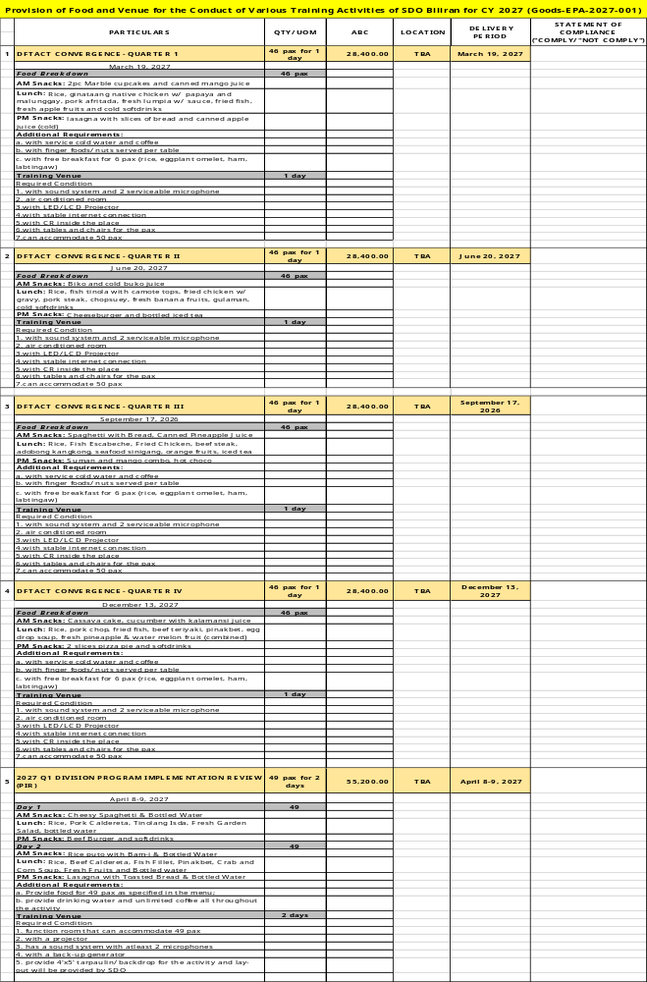
Technical Specifications
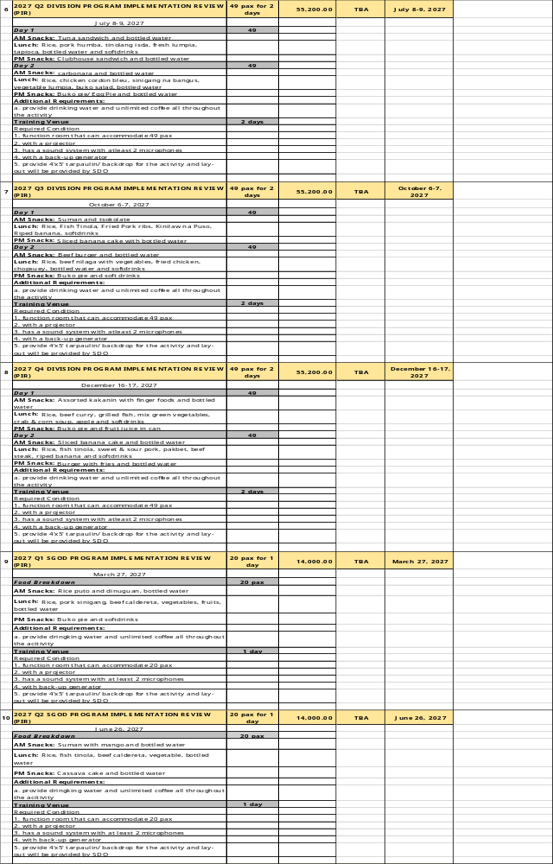
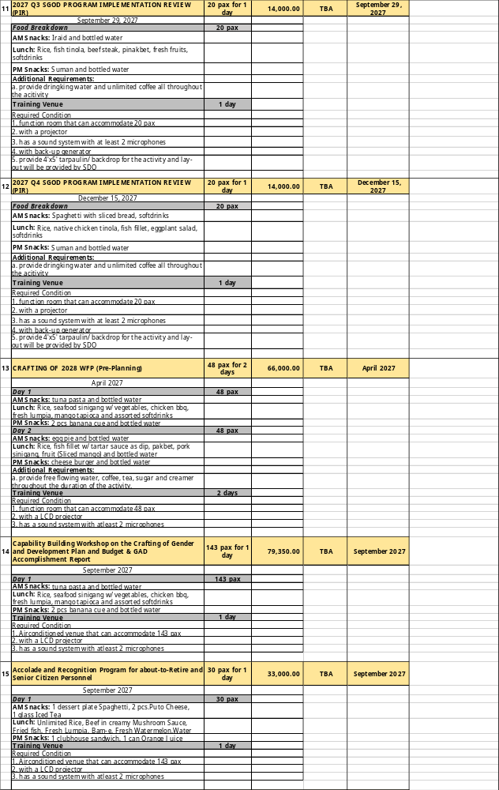
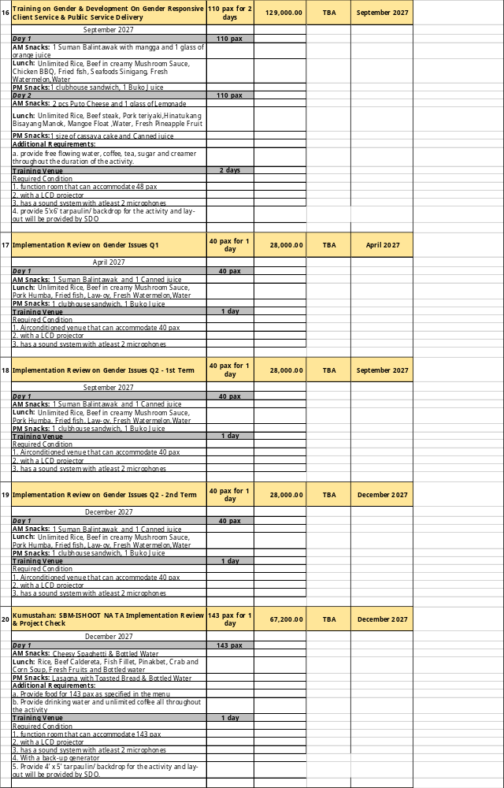
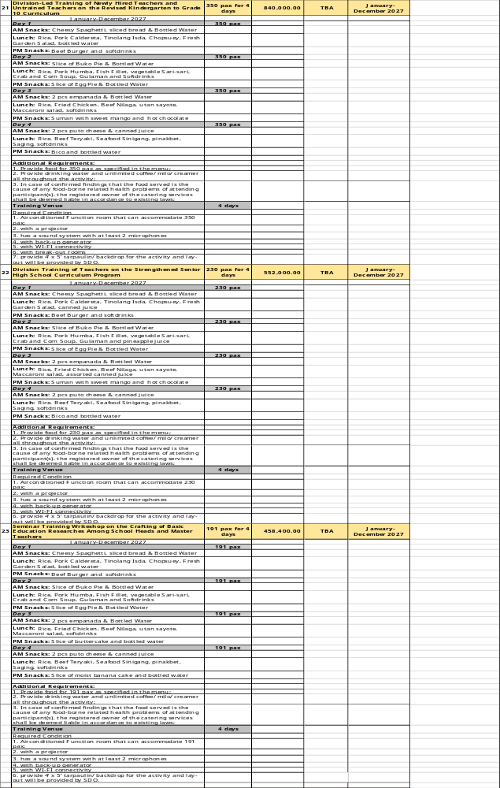
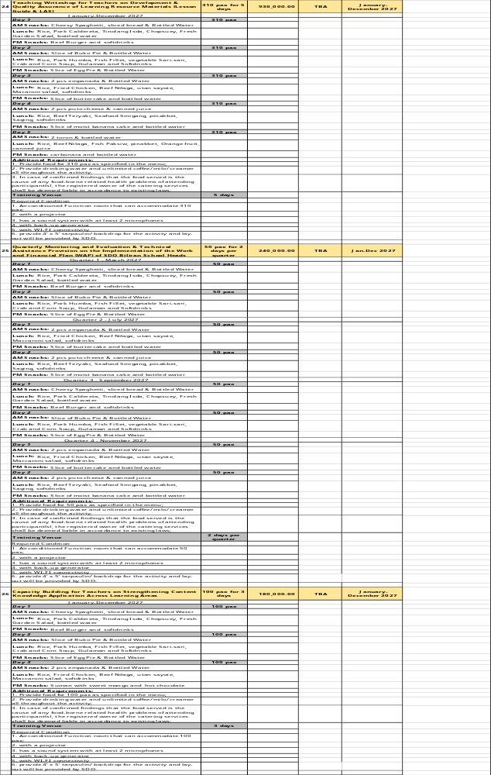
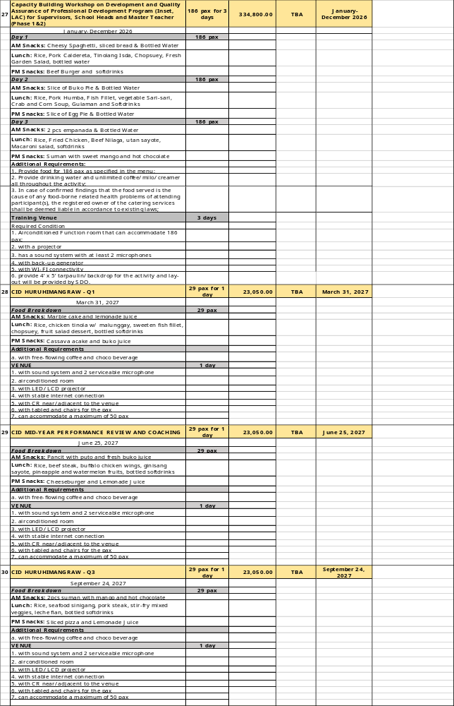

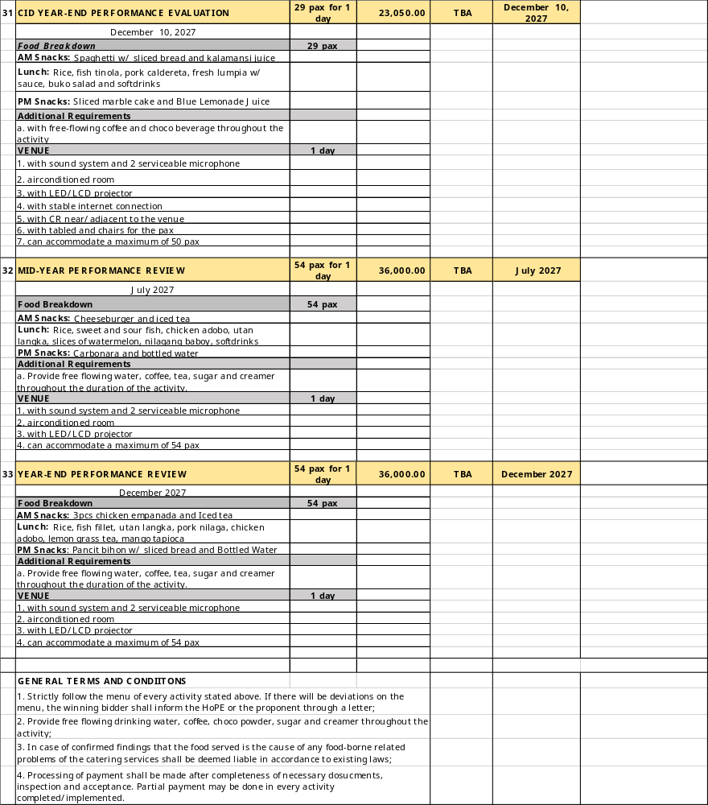

I hereby verify complying with all the above requirements.

___________________________________________________
Signature over the printed name of the authorized representative

___________________________________________________
Company name

___________________________________________________
Date

Section VIII. Philippine Bidding Document Related Forms

Notes to the Philippine Bidding Document Related Forms

The Bidder shall complete and submit with its Bid the Bid Form and Price Schedules in accordance with ITB Clause 13 with the requirements of the Bidding Documents and the format set out in this Section.

When requested in the BDS, the Bidder should provide the Bid Security, either in the form included hereafter or in another form acceptable to the Procuring Entity, pursuant to ITB Clause 16.

The Contract Form should incorporate any correction or modification to the accepted Bid resulting from price corrections when it is finalized at the time of contract award. The Price Schedule and Schedule of Requirements which form part of the contract should be modified accordingly.

The Omnibus Sworn Statement must be completed by all Bidders in accordance with ITB Clause 4.2. Failure to submit it with the Bid shall result in the rejection of the Bid and the Bidder’s disqualification.

The Performance Securing Declaration, if allowed and Bank Guarantee Form for Advance Payment shall be completed only by the successful Bidder in accordance with one of the forms indicated herein by the Procuring Entity, and pursuant to GCC Clause 13 and its corresponding SCC provision.

TABLE OF CONTENTS
Bid Form for Procurement of Goods 68
Price Schedule for Goods Offered from Within the Philippines 70
Price Schedule for Goods Offered from Abroad 71
Contract Form 72
Omnibus Sworn Statement Form 75
Bid Securing Declaration Form 79

Bid Form for Procurement of Goods

[Note: The duly accomplished form shall be submitted with the Bid]

BID FORM
Project Identification No.: [Insert number]

To: [Name of Procuring Entity]

Having examined the Philippine Bidding Documents (PBD) including the Supplemental Bid Bulletin Numbers [insert numbers], the receipt of which is hereby duly acknowledged, we, the undersigned, declare that:

- I/We have no reservation to the PBD, including the Supplemental Bid Bulletins, for the Procurement Project [Project Title];

- Select one, delete the other

- I/We undertake to deliver the Goods in accordance with the delivery schedule in the Schedule of Requirements;

- I/We offer to execute the Works for this Contract in accordance with the PBD;

- The total price of our Bid in words and figures, excluding any discount offered below, is [insert information]

- The discounts offered and the methodology for their application, if any, are: [insert information]; or indicate N/A if no discount offered]

- The total bid price in words and figures, after applying the applicable discount, includes the cost of all taxes, such as, but not limited to [specify the applicable taxes, e.g. (i) value added tax (VAT), (ii) income tax, (iii) local taxes, and (iv) other fiscal levies and duties], which are itemized in the [Select one, delete the other: the Price Schedules/ Detailed Estimates].

- This Bid shall remain valid within a period stated in the PBD, and it shall be binding upon me/us at any time before the expiration of that period;

- If our bid is accepted, I/we commit to enter to a contract and provide a performance security in the form, amounts, and within the times prescribed in the PBD, and hereby acknowledge the consequences under the IRR of RA No. 12009 on forfeiture of Bid Security or enforcement of Bid Securing Declaration and on Blacklisting.

Until a formal Contract is prepared and executed, this Bid, together with your written acceptance thereof and your Notice of Award, shall be binding upon the Bidder.

I/We understand that you are not bound to accept the Lowest Calculated Bid or any Bid you may receive.

I/We certify/confirm that we comply with the eligibility requirements pursuant to the PBD.

The undersigned is authorized to submit the bid on behalf of [Name of the Bidder] as evidenced by the attached [State the Written Authority].

I/We acknowledge that failure to sign each and every page of this Bid Form, including the attached Schedule of Prices, shall be a ground for the rejection of our bid.

Duly authorized to sign the Bid for and behalf of:

[Insert Bidder’s Name]

[Signature over Printed Name]
[Position/Designation]
[Date]

Price Schedule for Goods

Name of Bidder . Project ID No. ___. Page _ of ______

Pricing Details for Goods Offered from Within the Philippines

1 | 2 | 3 | 4 | 5 | 6 | 7 | 8 | 9 | 10
Item | Description | Source of Domestic Product, as certified by the Relevant Agency | Quantity | Unit price exw per item | Transportation and all other costs incidental to delivery, per item | Sales and other taxes payable if Contract is awarded, per item | Cost of Incidental Services, if applicable, per item | Total Price, per unit  (col 5+6+7+8) | Total Price delivered Final Destination  (col 9) x  (col 4)

Summary of Bid Prices

The Procuring Entity may modify the table below as necessary to comply with the requirements of the Procurement Project.

1 | 2 | 3 | 4
Item No. | Item | Particulars / Description | Total Amount

Name: ___________________________________________________________________

Signature:________________________________________________________________

Duly authorized to sign the Bid for and behalf of: _________________________________

Price Schedule for Goods

Name of Bidder . Project ID No. ___. Page _ of ______

Pricing Details for Goods Offered from Abroad

1 | 2 | 3 | 4 | 5 | 6 | 7 | 8 | 9
Item | Description | Country of origin | Quantity | Unit price cif port of entry (specify port) or cip named place  (specify border point or place of destination) | Total cif or cip price per item  (col. 4 x 5) | Unit Price Delivered Duty Unpaid (DDU) | Unit price Delivered Duty Paid (DDP) | Total Price delivered DDP  (col 4 x 8)

Summary of Bid Prices

The Procuring Entity may modify the table below as necessary to comply with the requirements of a specific Project.

1 | 2 | 3 | 4
Item No. | Item | Particulars / Description | Total Amount

Name: ___________________________________________________________________

Signature:________________________________________________________________

Duly authorized to sign the Bid for and behalf of: _________________________________

Contract Form

[Note: The duly accomplished form is not required to be submitted with the Bid but shall be submitted within ten (10) days after receiving the Notice of Award]

CONTRACT FOR [Insert Project Title]

This CONTRACT executed on the _____ day of __________ 20_____ by and between:

[Name of Procuring Entity], a government agency of the Republic of the Philippines, hereinafter called “the Entity”;

-and-

[Name of Supplier /Contractor/ Consultant] a company duly organized and existing under the laws of [city and country], with principal office at [insert address], hereinafter called “the Supplier”.

WHEREAS, the Entity invited Bids for certain goods and services/works/consulting services, particularly [Brief description of Project];

WHEREAS, the Supplier/Contractor/Consultant submitted a responsive bid and was awarded the contract for the procurement in the total amount of [Contract price in words and figures, including currency], hereinafter referred to as the “Contract Price.”

NOW, THEREFORE, for and in consideration of the foregoing premises, the parties hereby agree as follows:

            - Unless otherwise stated, terms and expressions used in this Contract shall have the same meanings as those assigned to them in the Conditions of Contract, which form an integral part of this Contract.

            - The following documents as required by the Implementing Rules and Regulations of Republic Act No. 12009 shall form part and be read and construed as integral parts of this Contract, viz.:

- Philippine Bidding Document (PBD); [Select one, delete the others]

- For Procurement of Goods

- Invitation to Bid;
- Instruction to Bidders;
- Bid Form, including all the documents/statements contained in the Bidder’s bidding envelopes, as annexes, and all other documents submitted (e.g., Bidder’s response to request for clarifications on the bid), including corrections to the bid, if any, resulting from the Procuring Entity’s bid evaluation;
- Bid Data Sheet;
- Schedule of Requirements;
- Technical Specifications;
- General and Special Conditions of Contract;
- Supplemental Bid Bulletins, if any; and
- Other contract documents that may be required by existing laws and/or the Entity.

- For Procurement of Infrastructure Projects

- Drawings/Plans;
- Specifications;/Scope of Work;
- Bill of Quantities;
- General and Special Conditions of Contract; and
- Supplemental Bid Bulletins, if any;

- For Procurement of Consulting Services

- General and Special Conditions of Contract;
- Terms of Reference;
- Request for Expression of Interest;
- Instructions to Bidders;
- Bid Data Sheet;
- Addenda and/or Supplemental/Bid Bulletins, if any;
- Bid forms, including all the documents/statements contained in the Bidder’s bidding envelopes, as annexes, and all other documents/ statements submitted (e.g., bidder’s response to request for clarifications on the bid), including corrections to the bid, if any, resulting from the Procuring Entity’s bid evaluation;
- Eligibility requirements, documents and/or statements;
- Performance Security;
- Notice of Award of Contract and the Bidder’s conforme thereto; and
- Other contract documents that may be required by existing laws and/or the Entity.

- Winning bidder’s bid, including the Eligibility Requirements, Technical and Financial Proposals, and all other documents or statements submitted;

- Performance Security;

- Notice of Award of Contract; and the Bidder’s Conforme thereto; and

- Other contract documents that may be required by existing laws and/or the Procuring Entity concerned in the PBD, such as but not limited to the Notice to Proceed and Warranty Security.

- In consideration of the Contract Price of [Contract Price in words and figures], or such other sums as may be determined in accordance with the terms of the Contract, the Supplier/Contractor/Consultant agrees to deliver and perform the items and related services for the [Project Title] described herein in accordance with the terms and conditions specified in the Contract and its annexed documents.

- The [Name of the Procuring Entity] agrees to pay the above-mentioned sum to the Supplier/Contractor/Consultant in accordance with the schedule and manner provided in the Bidding Documents and its annexes.

- Any dispute, difference, or claim arising out of or relating to this Contract, including its existence, validity, interpretation, breach, or termination thereof, may be submitted to arbitration or other form of alternative dispute resolution in accordance with the applicable law, such as Republic Act No. 9285 (Alternative Dispute Resolution Act of 2004) or Executive Order No 1008, series 1985 (Construction Industry Arbitration Law).

IN WITNESS WHEREOF, the parties hereto have caused this Contract to be executed in accordance with the laws of the Republic of the Philippines on the day and year first above written.

For the Procuring Entity | For the Bidder
Head of the Procuring Entity or Duly Authorized Representative  [Signature over Printed Name]  [Position/Designation]  [Date] | Duly authorized to sign the Contract for and behalf of [Bidders Name]:  [Signature over Printed Name]  [Position/Designation]  [Date]

Signed in the presence of:

[Name and Signature]  Witness – Procuring Entity | [Name and Signature]  Witness- Supplier

ACKNOWLEDGMENT

BEFORE ME, A Notary Public for and in the _______________________, City/Province of _____________________, this ______ day of _____________, 20______, personally appeared the above-named persons who have satisfactorily proven to me their identity, through their identifying documents written below their names and signatures, that they are the same persons who executed and voluntarily signed the foregoing instrument consisting of ____ pages, including this page where this Acknowledgement is written, which they acknowledged before me as their free and voluntary act and deed.

WITNESS MY HAND AND SEAL this ___ day of [month] [year].

NAME OF NOTARY PUBLIC

Notarial Commission No. ___________
Notary Public for ______ until _______
Roll of Attorneys No. _____
PTR No. __, [date issued], [place issued]
IBP No. __, [date issued], [place issued]

Doc. No. _______
Page No. _______
Book No. _______
Series of _______

Omnibus Sworn Statement Form

[Note: The duly accomplished form shall be submitted with the Bid]

REPUBLIC OF THE PHILIPPINES )
CITY/MUNICIPALITY OF ______ ) S.S.

Omnibus Sworn Statement

I, [Name of Affiant], of legal age, [Civil Status], [Nationality], and with residence at [Address of Affiant], after having been duly sworn in accordance with law, do hereby depose and state that:

  - Select one, delete the others:

- If sole proprietorship: I am the sole proprietor or authorized representative of [Name of Bidder] with office address at [Address of Bidder];

- If partnership, corporation, cooperative, or joint venture: I am the duly authorized and designated representative of [Name of Bidder] with office address at [Address of Bidder];

- If individual consultant not registered under a sole proprietorship, in case of Consulting Services: I am the individual consultant or authorized representative of [Name of Bidder] with office address at [Address of Bidder];

  - Select one, delete the others:

- If sole proprietorship: As the owner and sole proprietor or authorized representative of [Name of Bidder], I have full power and authority to do, execute and perform any and all acts necessary to participate, submit the bid, and to sign and execute the ensuing contract for [Project Title] of the [Name of the Procuring Entity] [insert “as supported by the attached duly notarized Special Power of Attorney” for authorized representative];

- If partnership, corporation, cooperative, or joint venture: I am granted full power and authority to do, execute and perform any and all acts necessary to participate, submit the bid, and to sign and execute the ensuing contract for [Project Title] of the [Name of the Procuring Entity], as supported by the attached duly notarized Special Power of Attorney, Board/Partnership Resolution, or Secretary’s Certificate, whichever is applicable;

- If individual consultant not registered under a sole proprietorship, in case of Consulting Services: As the individual consultant or authorized representative of [Name of Bidder], I have full power and authority to do, execute and perform any and all acts necessary to participate, submit the bid, and to sign and execute the ensuing contract for [Project Title] of the [Name of the Procuring Entity], as supported by the attached duly notarized Special Power of Attorney for authorized representative;

  - [Name of Bidder] is not “blacklisted” or barred from bidding by the Government of the Philippines or any of its agencies, offices, corporations, or Local Government Units, foreign government/foreign or international financing institution whose blacklisting rules have been recognized by the Government Procurement Policy Board; by itself or by relation, membership, association, affiliation, or controlling interest with another blacklisted person or entity;

  - Each of the documents submitted in satisfaction of the bidding requirements is an authentic copy of the original, complete, and all statements and information provided therein are true and correct;

  - [Name of Bidder] is authorizing the Head of the Procuring Entity or its duly authorized representative(s) to verify all the documents submitted;

  - Select one, delete the others:

- If sole proprietorship : The [Name of Bidder] and its spouse are not related by consanguinity or affinity up to the third civil degree to the Head of the Procuring Entity, Procurement Agent (if engaged), End-User or Implementing Unit, project consultants, head of the Project Management Office, or the members of the Bids and Awards Committee (BAC), the Technical Working Group, and the BAC Secretariat;

- If partnership : The partnership itself and the partners of [Name of Bidder] are not related by consanguinity or affinity up to the third civil degree to the Head of the Procuring Entity, Procurement Agent (if engaged), End-User or Implementing Unit, project consultants, head of the Project Management Office, or the members of the Bids and Awards Committee (BAC), the Technical Working Group, and the BAC Secretariat;

- If cooperative: The cooperative itself and members of the board of directors, general manager, or chief executive officer of [Name of Bidder] are not related by consanguinity or affinity up to the third civil degree to the Head of the Procuring Entity, Procurement Agent (if engaged), End-User or Implementing Unit, project consultants, head of the Project Management Office, or the members of the Bids and Awards Committee (BAC), the Technical Working Group, and the BAC Secretariat;

- If corporation, or joint venture: The corporation or joint venture itself, and officers, directors, and controlling stockholders of [Name of Bidder] are not related by consanguinity or affinity up to the third civil degree to the Head of the Procuring Entity, Procurement Agent (if engaged), End-User or Implementing Unit, project consultants, head of the Project Management Office, or the members of the Bids and Awards Committee (BAC), the Technical Working Group, and the BAC Secretariat;

- If individual consultant not registered under a sole proprietorship, in case of Consulting Services: The individual consultant and its spouse are not related by consanguinity or affinity up to the third civil degree to the Head of the Procuring Entity, Procurement Agent (if engaged), End-User or Implementing Unit, project consultants, head of the Project Management Office, or the members of the Bids and Awards Committee (BAC), the Technical Working Group, and the BAC Secretariat;

  - It is understood that failure to faithfully disclose its relationship with the Head of the Procuring Entity, members of the BAC, the TWG, and the BAC Secretariat, the head of the PMO or the end-user unit or implementing unit, and the project consultants of the Procuring Entity, or of the procurement agent by consanguinity or affinity up to the third civil degree, as well as its submission of beneficial ownership information containing false entries shall be subject to blacklisting under Section 100 of the Implementing Rules and Regulations (IRR) of Republic Act (RA) No. 12009, without prejudice to criminal and civil liabilities under applicable laws, including their accessory penalties, if any.

Select one, delete the rest:

- In case of corporations: [Name of Bidder] declares its beneficial ownership information consistent with its updated General Information Sheet or Beneficial Ownership Declaration Form or any other document duly submitted to the SEC and has maintained a valid and updated file therein in compliance with Sections 20.2.9.1, 81, and 82 of the IRR of RA No. 12009.

- In case of Foreign Bidders: [Name of Bidder] submitted an appropriate equivalent document in English issued by the country of the bidder concerned in accordance with Section 20.2.9.2 of the IRR of RA No. 12009.

  - [Name of Bidder] complies with existing labor laws and standards; and

  - [Name of Bidder] is aware of and has undertaken the following responsibilities as a Bidder:

- Carefully examine all of the Bidding Documents;

- Acknowledge all conditions, local or otherwise, affecting the implementation of the Contract;

- Made an estimate of the facilities available and needed for the contract to be bid, if any; and

- Inquire or secure Supplemental Bid Bulletin(s) issued for the [Project Title].

  - [Name of Bidder] did not give or pay directly or indirectly, any commission, amount, fee, or any form of consideration, pecuniary or otherwise, to any person or official, personnel or representative of the government in relation to any procurement project or activity.

  - In case advance payment was made or given to [Name of Bidder], failure to perform or deliver any of the obligations and undertakings in the contract shall be sufficient grounds to constitute criminal liability under existing laws.

IN WITNESS WHEREOF, I have hereunto set my hand this __ day of ___, 20__ at ____________, Philippines.

Duly authorized to sign the Bid for and behalf of:

[Insert Bidder’s Name]

[Affiant’s Signature over Printed Name]
[Position/Designation]
[Date]

JURAT

SUBSCRIBED AND SWORN to before me this _____ day of [month] [year] at [place of execution], Philippines. Affiant/s is/are personally known to me and was/were identified by me through competent evidence of identity as defined in the 2004 Rules on Notarial Practice (A.M. No. 02-8-13-SC). Affiant/s exhibited to me his/her [insert type of government identification card used], with his/her photograph and signature appearing thereon, with no. ______.

WITNESS MY HAND AND SEAL this ___ day of [month] [year].

NAME OF NOTARY PUBLIC
Notarial Commission No. ___________
Notary Public for ______ until _______
Roll of Attorneys No. _____
PTR No. __, [date issued], [place issued]
IBP No. __, [date issued], [place issued]

Doc. No. ________
Page No. _______
Book No. _______
Series of _______.

Bid Securing Declaration Form

[The duly accomplished form shall be submitted with the Bid if bidder opts to provide this type of bid security]

_________________________________________________________________________

REPUBLIC OF THE PHILIPPINES )
CITY/MUNICIPALITY OF ____________________ ) S.S.

BID SECURING DECLARATION
Project Identification No.: [Number]

To: [Insert name of the Procuring Entity]

I/We, the undersigned, declare that:

  - I/We understand that, according to your conditions, bids must be supported by a Bid Security, which may be in the form of a Bid Securing Declaration;

[Insert paragraph for Unsolicited Offer with Bid Matching]

I/We understand that upon conferment of the original offeror status under Section 30.6 of the Implementing Rules and Regulations (IRR) of Republic Act (RA) No. 12009, the offeror shall submit a Bid Securing Declaration within ten (10) days from the receipt of the certificate of conferment;

  - Select one, delete the other:

- I/We accept that: (a) I/we will be automatically disqualified from bidding for any procurement contract with any Procuring Entity upon receipt of your Blacklisting Order; and, (b) I/we will pay the applicable fine provided under the Guidelines on the Use of Bid Securing Declaration, within fifteen (15) days from receipt of the written demand by the Procuring Entity for the commission of acts resulting to the enforcement of the Bid Securing Declaration under Sections 52.2 (a), 63.2, 69.1 and 100, except 100.3 (c),of the IRR of Republic Act No. 12009; without prejudice to other legal action the government may undertake; and

(For Unsolicited Offer with Bid Matching)

- I/We accept that: I/we will be automatically disqualified from any procurement opportunity of the Procuring Entity for a period of one (1) year on the first offense, two (2) years on the second offense, and perpetually on the third offense without prejudice to other legal action the government may undertake.

  - I/We understand that this Bid Securing Declaration shall cease to be valid on the following circumstances:

        - Upon expiration of the bid validity period, or any extension thereof pursuant to your request;

        - I am/we are declared ineligible or post-disqualified upon receipt of your notice to such effect, and (i) I/we failed to timely file a request for reconsideration or (ii) I/we filed a waiver to avail of said right;

[Insert this paragraph for Unsolicited Offer with Bid Matching]

    - Upon contract award and the LCCRB is not the original offeror; or
    - I am/we are declared the bidder with the [Insert Award Criterion¹] and I/we have furnished the performance security and signed the Contract.

IN WITNESS WHEREOF, I/We have hereunto set my/our hand/s this ____ day of [month] [year] at [place of execution].

Duly authorized to sign the Bid for and behalf of:

[Insert Bidder’s Name]

[Signature over Printed Name]
[Position/Designation]
[Date]

JURAT

SUBSCRIBED AND SWORN to before me this _____ day of [month] [year] at [place of execution], Philippines. Affiant/s is/are personally known to me and was/were identified by me through competent evidence of identity as defined in the 2004 Rules on Notarial Practice (A.M. No. 02-8-13-SC). Affiant/s exhibited to me his/her [insert type of government identification card used], with his/her photograph and signature appearing thereon, with no. ______.

WITNESS MY HAND AND SEAL this ___ day of [month] [year].

NAME OF NOTARY PUBLIC
Notarial Commission No. ___________
Notary Public for ______ until _______
Roll of Attorneys No. _____
PTR No. __, [date issued], [place issued]
IBP No. __, [date issued], [place issued]

Doc. No. ________
Page No. _______
Book No. _______
Series of _______.

Checklist of Technical and Financial Documents

- TECHNICAL COMPONENT ENVELOPE

Class “A” Documents
Legal Documents
⬜ | - Valid PhilGEPS Registration Certificate (Platinum Membership) (all pages);  And
⬜ | - Registration certificate from Securities and Exchange Commission (SEC), Department of Trade and Industry (DTI) for sole proprietorship, or Cooperative Development Authority (CDA) for cooperatives or its equivalent document,  And
⬜ | - Mayor’s or Business permit issued by the city or municipality where the principal place of business of the prospective bidder is located, or the equivalent document for Exclusive Economic Zones or Areas;  And
⬜ | - Tax clearance per E.O. No. 398, s. 2005, as finally reviewed and approved by the Bureau of Internal Revenue (BIR).
Technical Documents
⬜ | - Statement of the prospective bidder of all its ongoing government and private contracts, including contracts awarded but not yet started, if any, whether similar or not similar in nature and complexity to the contract to be bid; and
⬜ | - Statement of the bidder’s Single Largest Completed Contract (SLCC) similar to the contract to be bid, except under conditions provided for in Sections 52.4.1.3 of the IRR of RA No. 12009, within the relevant period as provided in the Bidding Documents; and
⬜ | - Original copy of Bid Security in the form of:  Original copy of Notarized Bid Securing Declaration  or  If in the form of a Surety Bond, submit also a certification issued by the Insurance Commission; and
⬜ | - Conformity with the Technical Specifications, which may include production/delivery schedule, manpower requirements, and/or after-sales/parts, if applicable;
⬜ | - Original duly signed Omnibus Sworn Statement (OSS);  and if applicable, Original Notarized Secretary’s Certificate in case of a corporation, partnership, or cooperative; or Original Special Power of Attorney of all members of the joint venture giving full power and authority to its officer to sign the OSS and do acts to represent the Bidder; and
Financial Documents
⬜ | - The Supplier’s audited financial statements, showing, among others, the Supplier’s total and current assets and liabilities, stamped “received” by the BIR or its duly accredited and authorized institutions, or there shall be an attached BIR eAFS system generated Transaction Reference Number (TRN)/Confirmation Receipt in lieu of the manual “Received” stamp, for the preceding calendar year which should not be earlier than two (2) years from the date of bid submission; and
⬜ | - The prospective bidder’s computation of Net Financial Contracting Capacity (NFCC);  or  A committed Line of Credit from a Universal or Commercial Bank in lieu of its NFCC computation.
Class “B” Documents
⬜ | - If applicable, a duly signed joint venture agreement (JVA) in case the joint venture is already in existence;  or  duly notarized statements from all the potential joint venture partners stating that they will enter into and abide by the provisions of the JVA in the instance that the bid is successful.
Other documentary requirements under RA No. 12009 (as applicable)
⬜ | - [For foreign bidders claiming by reason of their country’s extension of reciprocal rights to Filipinos] Certification from the relevant government office of their country stating that Filipinos are allowed to participate in government procurement activities for the same item or product.
⬜ | - Certification from the DTI if the Bidder claims preference as a Domestic Bidder or Domestic Entity.
- FINANCIAL COMPONENT ENVELOPE
⬜  ⬜ |  | - Original of duly signed and accomplished Financial Bid Form; and  - Original of duly signed and accomplished Price Schedule(s)



For Second Stage of Competitive Dialogue under Section 29.4.2 of IRR of RA No. 12009.
For Comparative or Competitive Bidding for Unsolicited Offer under Section 30.7 of IRR of RA No. 12009.
Unless the Treaty or International or Executive Agreement expressly provides use of foreign government/foreign or international financing institution procurement guidelines.
Approved Budget for the Contract (ABC) refers to the budget for the contract duly approved by the Head of the Procuring Entity (HoPE), within the authorized amount in the General Appropriations Act (GAA), continuing, and automatic appropriations, or other authorized source of funds, in the case of National Government Agencies (NGAs); the corporate operating budget approved by the governing Boards, pursuant to Executive Order (EO) No. 518, s. 1979, entitled “Establishing a Procedure for the Preparation and Approval of the Operating Budgets of Government Owned or Controlled Corporations, in the case of GOCCs, GFIs, and RA No. 8292, or the “Higher Education Modernization Act of 1997”, in the case of SUCs; and the budget for the contract approved by the Sanggunian through an appropriation ordinance in the case of LGUs. For multi-year contracts, for which a Multi-Year Contractual Authority (MYCA) or an equivalent document is required, the ABC shall be the total project cost reflected in the MYCA or equivalent document (Section 5(a), RA No. 12009);
A brief description of the type(s) of Goods should be provided, including quantities, location of project, and other information necessary to enable potential Bidders to decide whether or not to respond to the invitation.
Reservation Clause
RA No. 8183, Act to assure uniform value of Philippine coin and currency
Section 76.1 The GPPB, once data is available from relevant agencies, shall maintain a registry of entities belonging to the following sectors: - Farmers, as certified by the Department of Agriculture (DA); - Fisherfolk as certified by the Bureau of Fisheries and Aquatic Resources (BFAR); - Persons with disabilities as certified by the National Council for Disability Affairs (NCDA) pursuant to RA No. 7277, otherwise known as the Magna Carta for Disabled Persons, as amended; - Solo parents as certified by the Department of Social Welfare and Development (DSWD); - Microenterprises and social enterprises as certified by the MSMED Council; - Startups, Spin-offs, and other forms of entity involved in Science, Technology, and Innovation (DOST), as may be applicable; - Cooperatives duly registered with the CDA pursuant to RA No. 6938, otherwise known as the Cooperative Code of the Philippines, as amended; and - Other relevant sectors as may be determined by the GPPB to ensure inclusivity and diversity in the procurement process.

